Appendix Eii: Lesson Sequence Planning Format - (KS1 and KS2)
Name: |  |  | Subject: Science - Light | Week Commencing: |  | Year Group: 3
Key objectives related to the EYFS/NC:  - recognise that they need light in order to see things and that dark is the absence of light  - notice that light is reflected from surfaces  - recognise that light from the sun can be dangerous and that there are ways to protect their eyes  - recognise that shadows are formed when the light from a light source is blocked by an opaque object  - find patterns in the way that the size of shadows change |  |  |  | Key Subject Knowledge (concepts):  - There are many different light sources  - Darkness is the absence of light  - Light travels from a source  - Light cannot pass through some materials  - Light travels in straight lines  - Light is reflected from surfaces  - We see things when light reflected from them enters our eyes
Assessment Opportunities  - Outcomes of the activities in each lesson How are the children using the science knowledge they have to draw conclusions and provide explanations for their observations/findings  - Each session to include a chance for retrieval practice to cover key knowledge from the previous lesson.  - Children to complete key activities for each lesson and outcomes will be recorded on a tracking grid. |  |  |  | Potential Misconceptions:  - We can still see where there is an absence of any light  - Our eyes ‘get used to’ the dark  - The moon and reflective surfaces are light sources  - A transparent object is a light source  - Shadows contain details of the object, such as facial features on their own shadows  - Shadows result from objects giving off darkness
Date | Learning Objective  Success Criteria | Lesson Outline (What is your role in the lesson and what are the children learning?)  Learning episode & Time (for example, retrieval, exposition, repetition, practice)  Remember: key questions, AfL strategies, adaptive teaching strategies and role of additional adults. |  |  | Key Vocabulary |  | Resources
 | To recognise that you need light to see and that dark is the absence of light. | Introduce the topic for the next few weeks. Explain that they will be learning about light and that they already know something about materials and what happens when they are used to make curtains (Bear cave activity in Y2)  What happens when it is dark? What can you see and what can’t you see?  What is light? Discuss prior knowledge and create KWL grid- keep until final session.  https://www.youtube.com/watch?v=1PsHHKwtXQU  BBC Bitesize: https://www.bbc.co.uk/bitesize/topics/zbssgk7/articles/z2s4xfr  What colours can we see best in low light?  Have resources ready on tables for groups of 4 to work with.  Put some items in a box  Cover the box with a blanket  Go underneath and try to work out what colours there are  Was it harder to see some colours than others?  Min- plenary; can chn explain what they found out? What vocabulary do they use? Use sentence stems to support responses: Make notes about this on tracking grid.  I think that…  An example of…  Share videos: Seeing in the dark:  https://www.bbc.co.uk/bitesize/clips/zb3s34j  Cliffside rescue at night: https://www.bbc.co.uk/bitesize/clips/zygvr82  Bring back as a group and pose the question: What is the brightest place in school?  TP for ideas- share responses and use working wall to gather suggestions and reasons.  Ask for reasons, again using sentence stems. Can they make connections with experiences? Where is bright/dark? Why? Does this change during the day? Why/why not?  Explain that they are going to be scientists and will be ‘gathering data’.  Model use of lux meter on iPads and how to record- create a chart with input from chn. What will they measure and how will they record?  Organise pairs for activity and assign roles- measurer and recorder and explain how this is to change at each location.  Then take a walk around the school measuring light in different locations and chn record their data in a table on the clipboard.  Bring back to the classroom. Need to decide which area is darkest and which is brightest and provide some reasons.  Allow 5 min for chn to work together to decide on their choices and draft reasons- use w/b.  Chn analyse their data and draw conclusions about where was the brightest and why.  Plenary: Is there any pattern? What might it be? Record notes for tracking grids. Make links to earlier videos.  Record findings on w.wall for next lesson. |  |  | Light  dark reflection natural artificial  source  shadow blocked  bright  dim  mirror  absorb transparent  opaque  translucent |  | Cardboard boxes  Various objects  Thick fabric to act as covers  Torches
PDF:  Evaluation of PDF: |  | Evaluation of children's learning and key points for the next session:
 | Identify how objects with different surfaces are more or less visible.  -Investigate the materials  -Work as a group to make a decision  -Record groups  -Explain reasons for decision | Review learning from last lesson, referring to w.wall ideas. What is light?  Why do we need to see?  What areas were the brightest and why?  What do you know about reflection? What is reflection Can you think of any reflective surfaces? What and where?  Watch: https://www.bbc.co.uk/bitesize/topics/zbssgk7/articles/zqdxb82  What did you notice about the mirror and black wall? TP: think, pair, share.  - When light from an object is reflected by a surface, it changes direction.  - It bounces off the surface at the same angle as it hits it.  - Smooth, shiny surfaces such as mirrors and polished metals reflect light well.  - Dull and dark surfaces such as dark fabrics do not reflect light well.  Organise groups of 4 and explain that they will be looking at different materials and thinking about what happens when they shine light on them.  Give the children a range of different materials and a torch. E.g. tin foil, paper, wood, metal, fabric.  Give them time to explore the reflectiveness of each material.  Ask them to record their findings in a table (see opposite).  Plenary:  Share findings and review how chn presented their data. Could they do it another way?  https://explorify.wellcome.ac.uk/en/activities/what-if/we-didnt-have-mirrors |  |  |  |  | A variety of materials – (black paper, white paper, yellow paper, mirror, foil, glass, plastic, fabrics, reflector strip), torch, light sensor/data logger, ruler  Torches  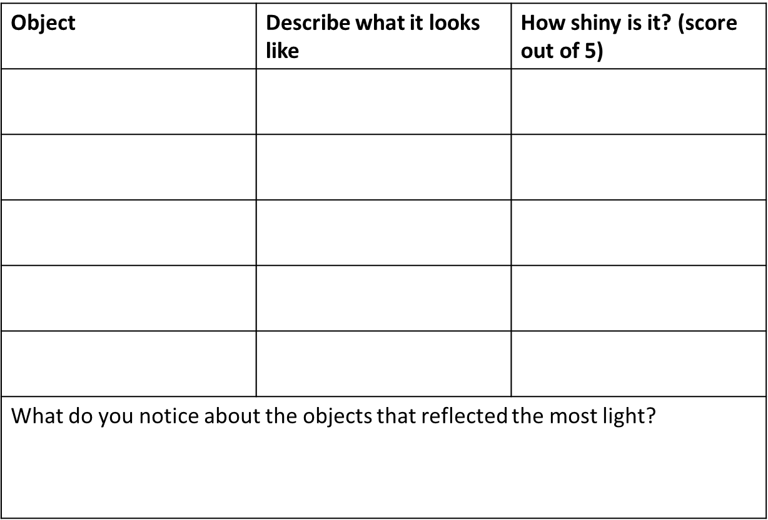
PDF:  Evaluation of PDF: |  | Evaluation of children's learning and key points for the next session:
 | To recognise that shadows are formed when the light from a light source is blocked by an opaque object  -Plan an investigation  --Observe  Record findings  -Pose questions | What do the chn know about properties of materials? What vocabulary can they remember? Add to vocab on w.wall.  Introduce opaque, translucent and transparent  https://www.dkfindout.com/uk/science/light/transparent-and-opaque-objects/  Children test a variety of objects to see if they create a shadow. They record their observations in a table – distinguishing between no shadow, faint shadow, dark shadow. They then draw their own conclusions and develop explanations using their knowledge of transparent, translucent and opaque materials from KS1.  - To carry out a simple test.  - To record observations in a table.  - To use observations to draw conclusions develop scientific explanations.  Plenary: Bring back- which objects created the clearest shadows? Why?  Share findings and chn have to use full sentences to explain what they found out. |  |  |  |  | A variety of objects to test – opaque, transparent and translucent (of various colours), Light sources (torch or lamp) and screen (mini whiteboards).
PDF:  Evaluation of PDF: |  | Evaluation of children's learning and key points for the next session:
 | To find patterns in the way that the size of shadows change.  -Plan an investigation  -Record findings  -Present data  -Provide explanations | What do chn know about shadows? When have they seen shadows? Link to work from last week.  https://www.bbc.co.uk/bitesize/clips/z8vfb9q  https://www.dkfindout.com/uk/science/light/shadows/  https://explorify.wellcome.ac.uk/en/activities/whats-going-on/shadow-shapes  If weather is bright, take this opportunity to go outside and investigate this in the playground.  Bring back in and explain that they will be working in pairs to create shadow sticks with black card and a lolly sticks. What do they want to investigate and why?  Allow chn to explore factors that affect the size of the shadow. This should be pattern seeking rather than systematic fair testing.  Children can use their observations to develop predictions and propose further enquiries to test these predictions.  Rolling plenary to share findings and suggest other possible enquiries.  Plenary: bring back together. What is a shadow? What affects its size? How might this be used for fun?  What do you think about using this as entertainment? What would develop this as an idea? |  |  |  |  | Black card, lolly sticks, bright torches, rulers and screen, torches.
PDF:  Evaluation of PDF: |  | Evaluation of children's learning and key points for the next session:
 | To identify which sunglasses are most effective at protecting our eyes.  Or: To recognise that light from the sun can be dangerous and that there are ways to protect their eyes | As summer is approaching, today we are going to think about which sunglasses are most effective at protecting our eyes.  What do chn already know about sunglasses?  https://www.youtube.com/watch?v=18xY0XygVGc  When do we use protection over eyes? Link to space missions and sun safety.  How can we measure the level of UV light that coms through a material?  Use UV beads and chn observe changes when they go outside.  Hand out bracelets of beads and ask chn to wear them on wrist. Go outside and observe what happens  Spend 5 minutes investigating the changes.  Bring back as a class and gather bracelets back in. What happened and why? What happened when you covered your wrist with your hand for a few moments? What was changing?  If we wanted to test sunglasses how could we do this?  Use TP to gather ideas. Chn record these on w/b.  Use discovery dog proforma to help with planning of a test. Chn will use UV beads to record the level of UV light that passes through the lenses.  Allow chn time to think about how they will do this and how they will record the results.  Give 20 min to carry out the activity. Chn use RSC colour chart to measure the UV index.  Rolling plenary- identify www and share with others as needed.  Give time warning so that activity draws to an end.  Bring back to carpet with w/b. TP to share conclusions and think about how this can be recorded.  Model a bar chart (if suggested) and then chn work on pairs to produce a record of their own.  Discuss merits of approaches used.  Plenary: How did you use your knowledge of materials and light in this session?  Aim to develop the use of appropriate vocabulary- what words can be used or were used last week?  Which lenses would be the most effective at minimising UV damage to an astronaut’s eyes?  Review last few lessons and revisit KWL grid- what can be added and what else would chn like to find out. If time, respond to their questions and plan a further session. |  |  |  |  | A variety of sunglasses (6-7 different pairs), torch, light sensor/data logger, ruler, UV beads (pink, blue, purple) and RSC Mission Starlight Colour Charts laminated – (See Online resources link below)  