Intensive Teaching and Practice 2: Understanding the school as a community Guide for Mentors and Coordinators

University of Leicester 2024-25

Contents

What is an ITP (Intensive Training and Practice)? 1

Instructions for ITT coordinators and Mentors 1

Professional Noticing 2

ITP 2: Understanding Classrooms and the school environment (3 days) 5

Outline 5

Day One: Who are the children you teach? 5

Day Two: School 5

Activity 1: Coming into school. 5

Activity 2: Lesson Observation 6

Activity 3: Understanding your school scavenger hunt 7

Activity 4: Noticing at social times 8

Day three: University 8

## What is an ITP (Intensive Training and Practice)?

An ITP is a ‘laser-focused look’ at a key aspect of teaching to make the link between theory and practice in a short time, with live feedback to help you to develop rapidly in foundational areas. The knowledge and understanding you gain will be something that you can build the rest of your practice upon.

In line with the requirements of the Core Content Framework, ITPs provide you with focused opportunities to:

* Discuss and analyse a particular approach with expert colleagues
* Observe expert colleagues and deconstruct their approaches to understand what makes them successful or unsuccessful
* Receive clear and effective mentoring and structured feedback from an expert colleague on that approach in order to improve your practice

## Professional Noticing

At the heart of our ITPs is the concept of professional noticing. Across all of the ITPs you will develop the skill of professional noticing and learn how to act upon what they have noticed in the classroom. Each ITP will contribute to developing a different element of professional noticing. Professional noticing will help beginning teachers to make sense of the complex environments in schools and classrooms and make informed decisions on how to respond to this. A range of research has shown that a well-developed capacity for noticing, contributes to an effective transition into practicing as a teacher.

In helping you to develop your professional noticing we are drawing upon a range of different theoretical work and research on noticing. Each of our ITPs build upon and help beginning teachers to develop their skill of noticing in professional contexts and then practicing reflecting on and acting upon what they have noticed. The way on which they link together and build on each other can be seen in the diagram below.

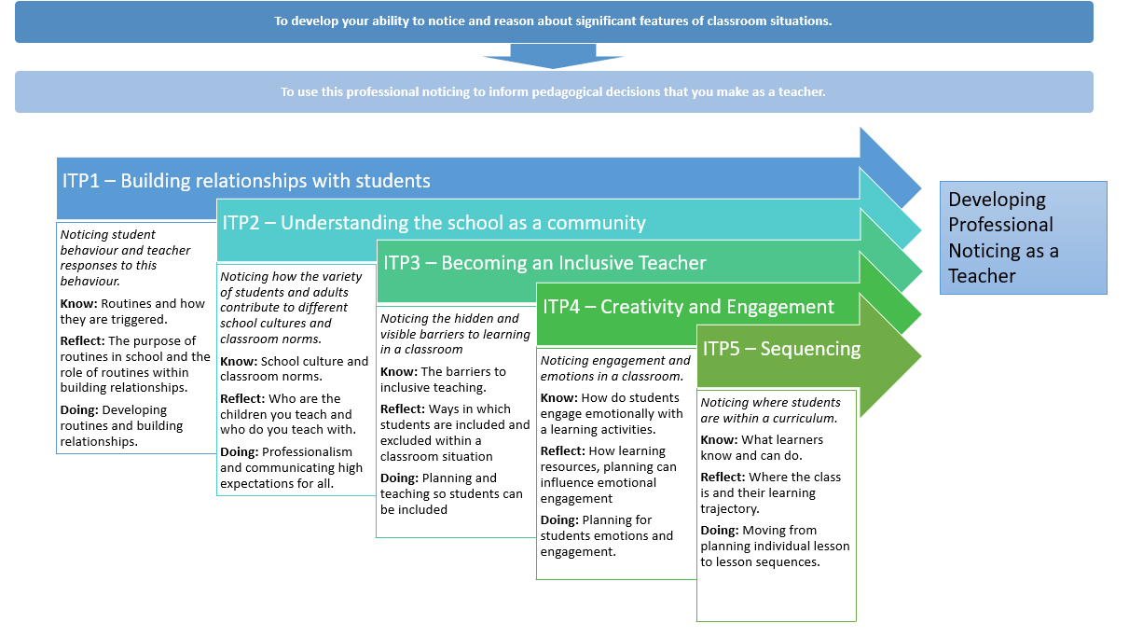

*Figure 1: Structure of ITP Noticing*

Central to this is that observing others performing professional practice, and noticing particular features, can lead to new learning. The concept of professional noticing differs from everyday noticing in that we pay attention to specific features and interpret what we observe from a professional perspective and framework. It is done with a clear intent and deliberatively. Rooney and Boud (2018) have suggested that noticing may contribute to helping beginning teachers to learn how to be able to understand the complex environments they work in and make more informed decisions about what they do in a classroom.

During the ITPs and school placement you should support You in their ability to notice in the context of a school environment. This will be done through structured observations, deliberate attention and preparation. Schools and classrooms are complex environments and paying attention to all of the different things that are going on in a classroom is difficult. This skill will go beyond the ITP and is a key feature of the focused observations that You should be completing each week. AS a mentor you can support them in developing observing you should try and focus on the area that you have been given to observe as an expert you should also help direct their attention on what they should be noticing. Jacobs et al (2010) looked at noticing in mathematical thinking and showed that along with being able to notice you need to be able to interpret, respond, and reflect on what you have observed.

As a co-tutor you should spend time deconstructing what You have observed, what was significant about what they observed, different interpretations of what they observed and what would be appropriate responses. One of the differences between professional noticing and everyday noticing is that with professional noticing it is done from the perspective of the profession and what is noticed is interpreted using concepts, principles and ideas from that profession. This can be seen in the comparison below. With professional noticing they are drawing upon ideas and principles of education to inform how they interpret and determine an appropriate response to what they noticed.

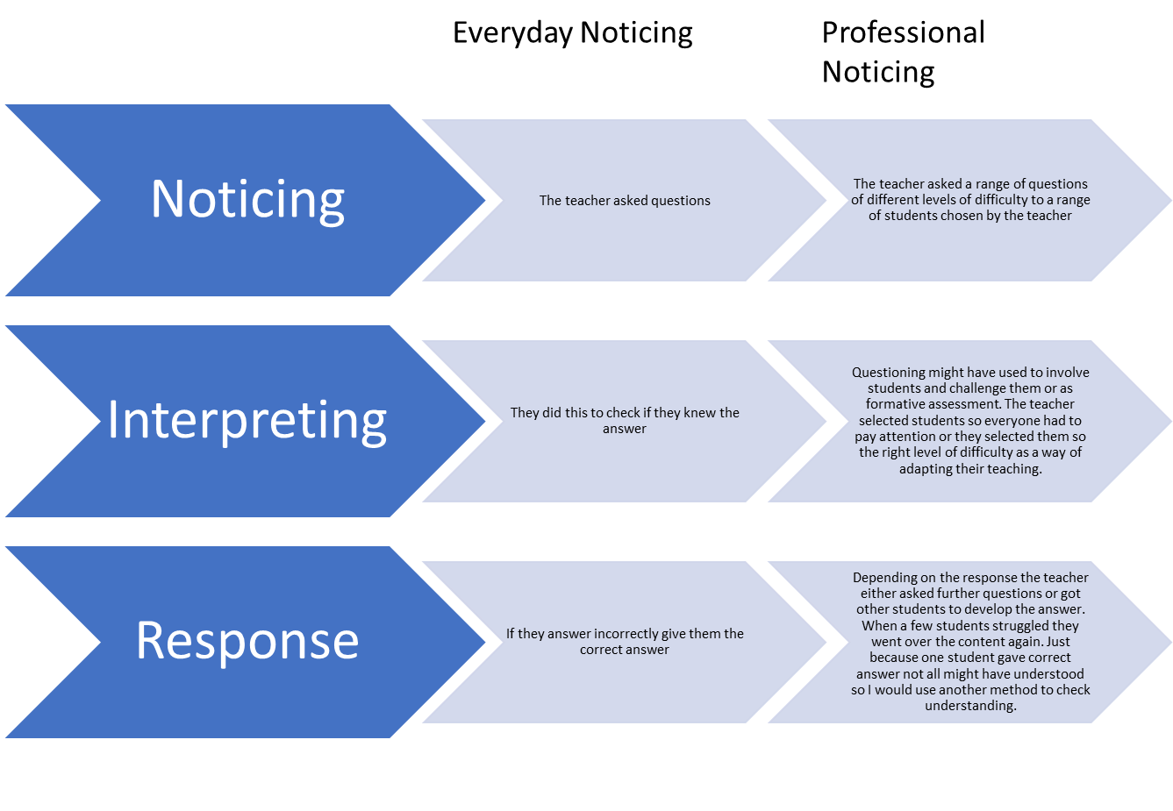*Figure 2: Difference between professional and everyday noticing*

The importance of noticing for you as a teacher is that it allows you to make more informed decisions in the classroom. Through the series of different ITPs, you will develop and practice the skill of professional noticing. This is a crucial skill in becoming a teacher as your ability to respond and adapt to situations in the classroom and improve your teaching practice depend on your ability to notice. Recent work by Gheyssen et al (2021) draw upon the importance of professional noticing as an important form of formative assessment and responsive teaching. In that the more able a teacher was able to notice within a classroom the better they were able to respond and adapt to the needs of the students in the classroom.

## ITP 2: Understanding Classrooms and the school environment (3 days)

**Focus:**

*Noticing how the variety of students and adults contribute to different school cultures and classroom norms.*

* **Know:** School culture and classroom norms.
* **Reflect:** Who are the children you teach and who do you teach with.
* **Doing:** Professionalism and communicating high expectations for all.

## Outline

**Day one:** University Based – Understand your schools and classrooms context

**Day two:** School: Noticing the culture and classroom environment

**Day three:** University: Deconstructing and planning

## Day One: Who are the children you teach?

In the university sessions you will be looking at schools that they will be going to on their placement. They will be considering the place of the school in the community, its geography, the demographics of the students in the school, the history of the school, and the heritage of the families of students who attend the school so that they are able to understand who the students they teach are and the world they come from before they enter the school gates and the different experiences students have of school as a result of this. They will look at Ofsted data, census data and performance data to gain a picture of the school.

## Day Two: School

With the understanding of how the variety of the student population, their families all contribute to the school culture during this day they will be doing a range of observations to help them notice and understand the school culture.

### Activity 1: Coming into school.

You should join the members of staff who are involved in the start of the day or to observe students coming into school.

**Noticing**

You should notice: How do the students arrive at school? What type of transportation do they take? What happens as they enter the school? What do the students do? What are the staff doing as they come into school?

**Interpretation**

What does the different ways that students arrive at school suggest about the school? What differences do they notice in how students are before and after they enter the school? What role do members of staff have in establishing the school culture?

### Activity 2: Lesson Observation

During this observation you are not to focus on the teacher but you will be looking at how members of the school community interact with each other. This will focus on how students and teachers communicate.

**Noticing**

How do teachers communicate with the students?

Do they communicate in the same way at the start of the lesson?

What differences are they’re between when the teacher is communicating with whole class, individuals or groups?

How do students communicate with the members of staff in the room?

How is it different to how they communicate with their peers?

Is there a difference in how they communicate before the lesson starts and during the lesson?

**Deconstruction**

What does how the members of the school community tell you about the school culture?

What are the norms around how members communicate with each other?

### Activity 3: Understanding your school scavenger hunt

You should have some time to explore the school. This should be done by yourself or with another PGCE student. You should try and answer as many of these questions in a lesson. The purpose of this activity is to help them to understand the geography of the school and the messages that they can get from walking around the school regarding the school culture. This will be done through a scavenger hunt.

**Scavenger Hunt**

What is the closest photocopier to your department?

How do students move around the school? Is there any one-way systems or rules on how they get around the school?

How long does it take to get from one end of the school to the other?

Find the staff room. What do you notice about the staff room?

Find the school library. How is it being used? What is the librarian’s favourite book?

Find the English Department. What displays do they have on the walls?

Find the Art, Design and Technology classrooms. How is it different to other spaces in the school?

Find the reprographics department. How many photocopiers do they have? Do the members of staff have any pets?

Find the IT department. How many people are part of that department? Do they prefer sweets or chocolate?

What’s the name of the school receptionist?

What posters and displays are in the reception area?

Does your department have an office/workspace?

Where do people in your department work?

Are there any trophies, achievements, plaques displayed in the school? What are they for?

What posters, displays are in the corridors?

Can you find any of the school rules on display? How many rules do they have?

How many staff toilets are there?

How many student toilets are there in the school?

Find a quiet place in the school. Where is it?

Find the noisiest place in the school. Where is it?

What’s the name of the designated Safeguard Lead?

### Activity 4: Noticing at social times

Join a member of staff while on duty during either break or lunch duty. How do the students interact with each other during social time? How do the staff interact with students during this time? What are the students doing during this time? How do the members of staff interact with each other?

## Day three: University

Deconstruct what they have observed from what you have observed what can you tell about the school culture? What did you notice about the students in the school?

**Activity: Perceptions of the school**

Search for the school on google. In what ways has the school featured in the news? Go on the school’s website. Can you find any news from the school? What do they include in their newsletters? Look at their previous Ofsted reports what have they said about the school?

What did you notice about the classrooms and students that you met while at school?

**Activity: Preparing for your placement**

How will you interact with students?

How will you interact with other members of staff?

**References**

Cowie, B., Harrison, C. and Willis, J. (2018) ‘Supporting teacher responsiveness in assessment for learning through disciplined noticing’, *The Curriculum Journal*, 29(4), pp. 464–478. Available at: <https://doi.org/10.1080/09585176.2018.1481442>.

Gheyssens, E. *et al.* (2021) ‘Creating inclusive classrooms in primary and secondary schools: From noticing to differentiated practices’, *Teaching and Teacher Education*, 100, p. 103210. Available at: <https://doi.org/10.1016/j.tate.2020.103210>.

Gibson, S.A. and Ross, P. (2016) ‘Teachers’ Professional Noticing’, *Theory Into Practice*, 55(3), pp. 180–188. Available at: <https://doi.org/10.1080/00405841.2016.1173996>.

Jacobs, V.R., Lamb, L.L.C. and Philipp, R.A. (2010) ‘Professional Noticing of Children’s Mathematical Thinking’, *Journal for Research in Mathematics Education*, 41(2), pp. 169–202. Available at: <https://doi.org/10.5951/jresematheduc.41.2.0169>.

Larssen, D.L.S. *et al.* (2018) ‘A literature review of lesson study in initial teacher education: Perspectives about learning and observation’, *International Journal for Lesson and Learning Studies*, 7(1), pp. 8–22. Available at: <https://doi.org/10.1108/IJLLS-06-2017-0030>.

Rooney, D. and Boud, D. (2019) ‘Toward a Pedagogy for Professional Noticing: Learning through Observation’, *Vocations and Learning*, 12(3), pp. 441–457. Available at: <https://doi.org/10.1007/s12186-019-09222-3>.