PGCE Mentoring Handbook
School of Education

Contents

- Principles of mentoring at the University of Leicester

- Overview of our mentoring curriculum

- Overview of Phases

- Roles and responsibilities
  - Lead mentors
  - General mentors
  - ITE coordinators
  - University tutors
  - Trainees

- Mentor training
- Partnership agreements


Principles of Mentoring at the University of Leicester

We have adopted the concepts of Knowing, Doing, Being and Becoming (Craig, 2018) as a way to articulate the complex process of integrating theory and practice. This underpins our curriculum structure of taught sessions (professional, academic and subject elements) and school practicums, as outlined in the framework below.
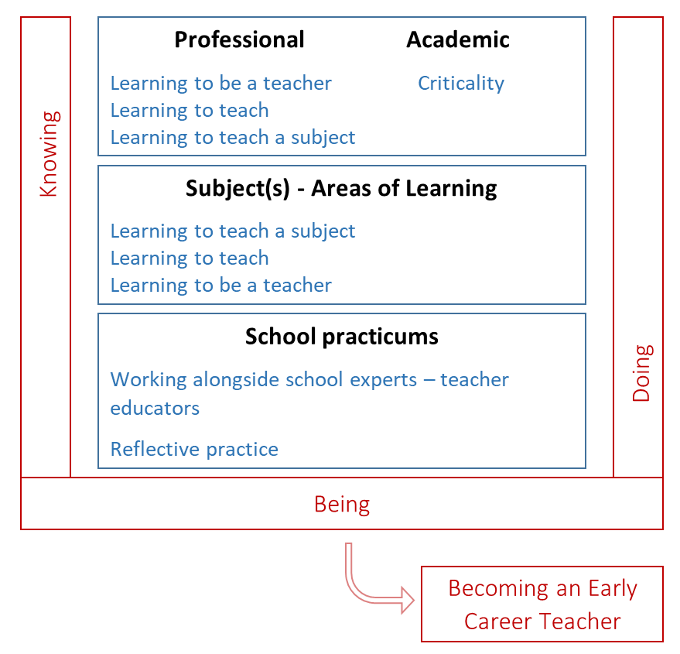

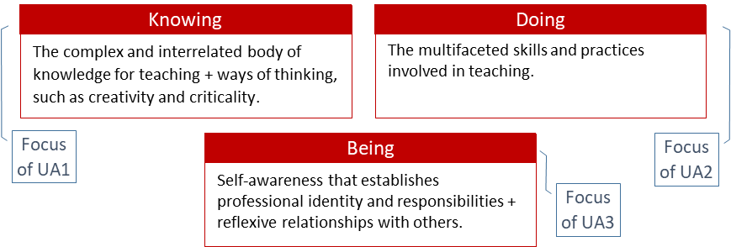

The CCF is the government specified minimum curriculum entitlement; it is embedded throughout the course.
The CCF is structured in five areas¸ and is related to the Teachers’ Standards (S1-8 plus Part 2) our curriculum adopts the same overall structure. Trainees are assessed against the Teachers’ Standards at the end of the course.

Overview

This schedule builds on the university’s pre-existing partnerships, structures and strengths to offer a research-led, tailored curriculum that aims to:
- ensure all trainees have access to expert mentors to support the delivery and practice of training.
- add value to all University of Leicester PGCE students through ensuring and continuing to develop high-quality mentoring across all partners.
- add value to all University of Leicester PGCE mentors through an adaptive curriculum that grows with the mentor.
- provides a development route for all mentors towards further accreditation (e.g. NPQLTD, MA in Education)
- supports partnerships by offering schools a development pathway for staff by choosing to have University of
Leicester trainees

Glossary

Lead Mentor | Design and implement the mentoring curriculum, including mentor training and quality assurance
General Mentor | Mentors in schools who support and guide trainees during their placement
Lead Partner | ITE partners who recruit and place their own trainees
CCF | Core Content Framework – the minimum requirement that ITE provision must provide by law ITT Core Content Framework (publishing.service.gov.uk)
ITE coordinator | School colleague responsible for the organisation and overview of placements within a partnership school
Co-Tutor | Mentors in secondary schools who support and guide trainees during their placement
CARD | Curriculum and Assessment Review Document – used to assess the trainees formatively against placement expectations and the summatively against the Teachers’ Standards  (2012)
Placement | A school practicum which takes place in a partnership school
Visiting Tutor | A university tutor who visits primary trainees during their placement
Trainee | A student teacher
Personal Tutor | A university tutor who is responsible for monitoring the progress of the trainee during the  PGCE year
ITP | Intensive Training and Practice – Intensive training and practice is a specific and focused element of the teacher training curriculum
School Experience  Site | An open website dedicated to all documentation and information relating to the school practicums
Mentor Training | Training for all mentors which meets the required hours as stipulated by the DfE

Mentoring Roles and responsibilities
This section should be looked at in conjunction with the Partnership Agreements (section 7)

Role | Overview
Lead Mentor | It is the role of the Lead Mentor to:  - report to the Director of Initial Teacher Education as required.  - oversee and report on the quality of mentoring across the UoL ITE programme • ensure UoL’s mentoring programme is compliant with all DfE requirements.  - ensure that the UoL mentoring programme upholds the Equalities Act (2010) and supports trainee and mentor wellbeing.  - liaise with schools and UoL to ensure cohesion between UoL programme requirements and placements in school; that the Partnership Agreement is being adhered to.  - train and support mentors to meet requirements for ITP weeks.  - contribute to the design and delivery of ITP weeks  - contribute to the strategic and operational planning of mentoring across UoL ITE programmes.  - support mentors to carry out their role within the programme.  - liaise with schools where support plans are required and/or put in place to have oversight of support being offered and progress of trainee/mentor.  - notify the Director of Initial Teacher Education if any provider is not meeting its Partnership Agreement.  - contribute to the strategic and operational planning of training for mentors.  - lead and contribute to the design and delivery of training for mentors and school-based ITE leads, including the mentoring conference.  - contribute to the design and delivery of phase and/or subject-specific mentoring training and/or materials.  - quality assure mentoring across UoL ITE programmes, including school visits where required.  - support the induction of new mentors though training and quality assurance visits.  - oversee the progress for any mentors identified for additional support/not meeting programme requirements.  - ensure they attend Lead Mentor training  - keep up to date with mentoring research  - attend Lead Mentor meetings  - ensure that workloads for trainees and mentors is manageable, and supports wellbeing.  - meet with external moderator and/or Ofsted Inspectors as required.

General Mentors | It is the role of Mentors to:  - ensure compliance with all requirements as set out in the Partnership Agreement.  - build a trusting, supportive relationship with their trainee(s) focused on developing the trainee(s) in their initial teacher education year.  - be a model of the professional standards required of teachers and of effective teaching practice.  - provide a suitable timetable following UoL programme guidelines and opportunities for the trainee(s) to involve themselves in the wider life of the school.  - ensure trainees are provided with and complete an induction to their placement school, including contextualised safeguarding training, access to school policies, health and safety and fire training.  - ensure compliance with the Equalities Act (2010).  - provide meeting time, specific and relevant feedback, and constructive support for the trainee(s) during their placement.  - liaise with school-based mentoring leads and/or lead mentors over trainee progress.  - ensure any concerns or issues are raised in a timely and supportive way.  - keep updated on the CARD each week to ensure cohesion between UoL and school-based learning  - attend UoL training to ensure clarity on the role of the mentor, the UoL programme and develop mentoring skills.  - oversee the completion of any documentation related to the trainee, including reporting on progress and support plans.  - support UoL quality assurance processes  - meet with External Moderator and/or Ofsted Inspectors as required.  In addition Mentors are entitled to:  - receive training that supports them in their roles and offers opportunities for further professional development  - be supported in their role by the Lead Mentor  - by supported in their role by the school colleagues  - receive all relevant information and course documentation to support them in their role.
Trainees | - take responsibility for their own development and progress  - Ensure that they engage with course materials in preparation for their placements  - Complete all necessary documentation before weekly review meetings  - Plan lessons to share with mentors at least 24 hours beforehand and make any suggested alterations  - Complete and upload any necessary assessment documentation during the placement  - Send lesson plans and information to the visiting tutor prior to a visit  - Engage with and enact all relevant school policies during the placement  - Meet with external moderators and/ or Ofsted as required  - Ensure subject knowledge is sufficient to teach relevant subjects to a high standard • Engage with the wider life of the school during placement
University tutors | •  • | Monitor the progress of the trainee through school visits and scrutiny of oneline portfolio Liaise with mentor/ co-tutor and trainee to ensure placement expectations are being met by all involved
 | • | Communicate effectively with school colleagues and trainees to ensure they receive up to date information
 | • | Support the mentor/co-tutor/ ITE coordinator and/ or trainee during the placement
ITE coordinators | •  • | Support the co-tutor/ mentor and/ or trainee during their placement  Liaise with the university tutor to ensure placement meets requirements

Mentor Development Programme

The University of Leicester will deliver training through a number of mechanisms, to ensure:

- all mentors are able to receive training and meet requirements of hours set out by DfE.
- training develops expertise in subject and phase approaches
- mentors’ knowledge and understanding of the ITT curriculum, UoL curriculum and mentoring is built
- mentors have sufficient training to support trainee(s)
- mentors have been trained in all areas of the mentor training curriculum
- training can be tailored to individual mentor need, to avoid mentors repeating training.

DFE requirements for hours are shown in brackets

General Mentors
Mentors are selected by School leadership colleagues in accordance with the criteria set out in the UoL Partnership Agreement. Lead Mentors will liaise and quality assure this to ensure criteria is being followed.
Initial Training |  |  | Initial Hours
Induction to UoL Mentoring Development |  |  | 2
Programme Overview Video
  0.5
Weekly CARD updates
  10
Quality Assurance Visit |  |  | 4
 | Phase Meetings |  |  | 4.5
  Total
  21 (20)

Modes of Delivery – General Mentor Development materials

Induction to UoL Mentoring Training
Remote

All new mentors joining our programme will attend an Induction to Mentoring training session run by Lead Mentors. These will be phase specific, and focus on introducing new mentors to the principles and expectations of the programme. Mentors will learn what is expected of them and what roles they will undertake. They will be introduced to the CARD and their role in assessment.

Programme Overview Video
Asynchronous

All mentors will be provided with access to a video that covers the core information for the programme, including working with the CARD, the curriculum overview, how to assess trainees and sources of support. New mentors will be required to watch prior to attending Induction to UoL Mentoring Training. Returning mentors will have access to the video, in case they have questions through the year and wish to use the video to support them in their role.

Weekly CARD Updates
Reading Materials

Central to the UoL approach to mentoring is the use of the CARD. Each week detailed guidance is sent to mentors on the upcoming focus of the CARD. Reading through this guidance is a core activity for mentors on this programme. Each update will build mentor knowledge about the curriculum and ITT focuses. CARD updates will also be tailored by Lead Mentors to include training for mentors on developing mentoring practice. A one page summary on the focus of mentor development for that week

Quality Assurance Visit
Face to face

Every mentor will receive at least two QA visits a year with a focus on trainee progress and mentor development. Visits to new mentors will be prioritised and scheduled early in placements. Lead Mentors will ensure that QA visits focus on calibrating judgements, and providing coaching/mentoring for mentors to develop their knowledge of the UoL curriculum and own mentoring practice.

Phase Meetings
Face to face/Remote

All mentors will be required to attend three 1.5 hour long phase meetings, schedule once per term and led by Lead Mentors. These will use feedback and quality assurance visits to identify areas for development for mentors. The focus will be on developing mentoring skills and expertise. Lead Mentors will work alongside schools to plan and tailor sessions to their cohort each year.

Lead Mentors
Lead Mentors are current University of Leicester ITE staff. The university’s rigorous recruitment and appraisal processes ensure that its ITE staff are experts in teacher education and phase or subject. This ensures the UoL meets the following DfE criteria:

The lead mentor/mentor leadership team must have particular expertise in the evidence base for effective initial teacher training, including programme design and content selection.
Initial Training | Initial Hours
Mentoring Leadership half-day conference | 6
Termly Lead Mentor planning and preparation meetings | 9
Self-Guided Study | 6
Mentoring Masters Module | 10
Total | 31 (30)

Modes of Delivery – Lead Mentor Development materials

Joint Quality Assurance Visit
Face to face

All mentors will complete a joint quality assurance visit with a University tutor and/ or a Lead Mentor to calibrate judgements and ensue clarity around procedures and expectations for QA visits. Lead Mentors will provide feedback to Mentors and senior leadership colleagues to support them in conducting future QA visits.

Mentoring Leadership Conference
Face-to-face

Termly half-day conferences will be run by UoL Lead Mentors for new Lead Mentors and Mentoring Leadership Team. These will last for 3 hours, with attendance required from all new Lead Mentors

The first hour will focus on ensuring understanding of upcoming programme requirements for the term and ITT focuses. Training will support attendees to know curriculum focuses, assessment requirements and other key information about the programme.

The remainder of the conference will be designed by Lead Mentors in response to identified training needs though monitoring, feedback and quality assurance of the programme. There will be phase and/or subject specific focuses, and opportunities to work collaboratively with Mentoring Leadership Teams on the design of mentoring.

Mentoring Masters Module
Asynchronous

All new Lead Mentors will be required to complete at least 10 hours of the UoL’s accredited Masters level Mentoring Module training materials.

Self Guided Study

All Lead Mentors will be required to read through materials that introduce the theoretical background and practical behaviours of our approach to mentoring. This is to ensure that all Lead Mentors have a strong understanding of the principles of our approach to mentoring and can use with their mentors.

Self Guided Study - Lead Mentors

All Lead Mentors will be required to identify and agree with the Director of ITE a focus area each year to develop their specialism in. These will be linked to areas of responsibility within their Lead Mentor role. For example, a Lead Mentor who is designing Phase Meetings on ‘Difficult Conversations’ for mentors could elect to use their designated time to read up/attend training on this to deepen their own knowledge.

Termly Lead Mentor Planning and Preparation Meetings
Face-to-face

All Lead Mentors will attend a termly Lead Mentor Planning and Preparation Meeting. Meetings will review current provision and support planning for future delivery. Through these Lead Mentors will develop detailed knowledge of the curriculum and programme to support them in their role.

Partnership Agreements
There are three versions of the Partnership agreements.
- Primary University of Leicester Partnership Agreement
- Secondary University Partnership Agreement
- Lead Partner Partnership Agreement
Each agreement outlines the roles and responsibilities for all stakeholders during each placement.
Agreements are approved by the following parties:
- School of Education Committee
- College of Social Science, Arts and Humanities Education Committee
- Partnership Management Group
Partnership Agreements are sent to partnership schools, prior to the commencement of the placement, to be signed and approved

Mentoring grants
During the academic year 2024-25, mentors are entitled to apply for DfE delivery grants.
All General Mentors who complete the required amount of training hours (20 hours) as stipulated by the DfE, are eligible to apply for DfE funding General mentor training Conditions of grant (publishing.service.gov.uk)
Schools can claim up to £876 (£43.80 per hour) per General Mentor. They can claim this funding at the end of the 2024-25 academic year.
The funding can be used to cover costs incurred by the school in implementing the general mentor role, including backfill of the mentor whilst they were training. If for any reason, the placement is not completed by the trainee, the mentor can claim for the hours of mentor training which have already been completed.
Payments will be made in arrears from September 2025. Placement schools will be able to submit a claim via a new GOV.UK service. The service will open in Spring 2025 and schools will be able to submit their claims once their mentors have completed their training. Schools must complete their claims by the end of July to receive payment from the Educational and Skills Funding Agency (ESFA) in late September/early October. If schools miss the payment window, they will be able to submit a claim in September, with payment being made in December 2025. DfE will begin communicating details of this new service to schools and providers from September 2024. If you would like additional information about the payments email ittmentor.funding@education.gov.uk

