# Curriculum Assessment and Review Document (CARD): Phase 2

|  |  |  |  |
| --- | --- | --- | --- |
| **Name: Trainee Teacher** | **Name: Teacher Mentor** | **School** | **Year group** |
|  |  |  |  |

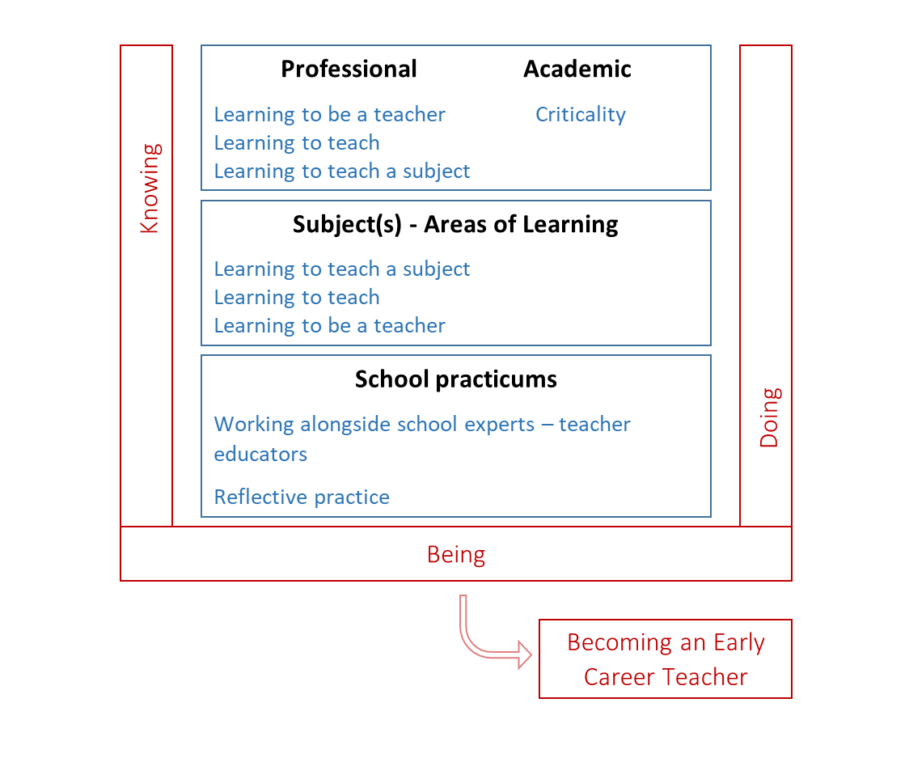We have adopted the concepts of Knowing, Doing, Being and Becoming (Craig, 2018) as a way to articulate the complex process of integrating theory and practice. This underpins our curriculum structure of taught sessions (professional, academic and subject elements) and school practicums, as outlined in the framework below.

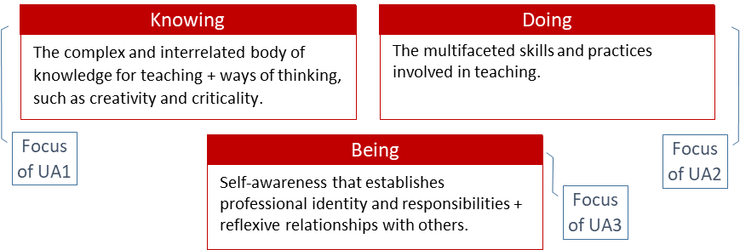

## Our Curriculum: Relationship to the Core Content Framework (CCF) and the Teachers’ Standards

|  |  |  |  |
| --- | --- | --- | --- |
| **Our Curriculum** | **CCF Priorities** | **CCF term** | **DfE Teachers’ Standards and statements** |
| **A) Academic: Postgraduate Study** | *Links to all five other areas e.g. through developing knowing, doing, being through engagement with university assignments.* | | |
| **B) Professional Behaviours and Values** | **Professional behaviours CCF5** | Professional Behaviours | **S8** Fulfil wider professional responsibilities  **Part 2** Personal and professional conduct |
| **C) Behaviour and Relationships** | **Behaviour management CCF1** | High Expectations  Managing Behaviour | **S7** Manage behaviour effectively  **S1** Set high expectations |
| **D) Pedagogy** | **Pedagogy CCF2** | How Children Learn  Classroom Practice  Adaptive Teaching | **S2** Promote good progress  **S4** Plan and teach well-structured Lessons  **S5** Adapt teaching |
| **E) Curriculum** | **Curriculum CCF3** | Subject and Curriculum | **S3** Demonstrate good subject and curriculum knowledge |
| **F) Assessment** | **Assessment CCF4** | Assessment | **S6** Make accurate and productive use of assessment |

The CCF is the government specified minimum curriculum entitlement; it is embedded throughout the course.

The CCF is structured in five **areas¸** and is related to the Teachers’ Standards (S1-8 plus Part 2) according to the table; our curriculum, outlined in this document, adopts the same overall structure. Trainees are assessed against the Teachers’ Standards at the end of the course; this document, CARD, provides the benchmark statements against which their progress is formatively assessed during Phase 1.

## Phase 2 placement – ‘curriculum deliverer’

Prior to 2021, professional judgments about a trainee’s progress were made against the Teachers’ Standards. You used your professional lens and expertise to make judgments in relation to the progress expected for trainee teachers *and* the context in which they are working. We will be drawing on your professional expertise to make these same judgments against our curriculum, as summarised in our benchmark statements here in CARD Phase 2. The statements indicate what a trainee teacher should ‘look like’ at the end of phase 2, rather than the end of the course.

## Curriculum Structure: Overview Phase 2 placement – ‘curriculum deliverer’

The table below outlines the overall structure of the curriculum trajectory. It contains the **5 areas** related to the CCF structure plus the Academic: Postgraduate Study area.

The Themes and Focus provide the headlines for the curriculum for Phase 2; further details of the curriculum will be discussed at the Teacher Educator Development meeting, and supporting documentation will be available on Blackboard.

The *Knowing* and *Doing* provide the highlights of this ‘curriculum deliverer’ phase, and are expanded upon over the subsequent pages. More of the Knowing benchmark statements are orange, and will be assessed through university assessments. We are asking you to focus on the green boxes, which are mainly but not exclusively the Doing statements; we appreciate there is much interdependency. (Section, (A) Academic: Postgraduate Study, relates to academic assignments - assessed by university tutors).

|  |  |  |  |  |
| --- | --- | --- | --- | --- |
| **Theme** | **Focus for Phase 2** | **Knowing** | **Doing** | Review |
| (A) Academic: Postgraduate Study | | | | |
| Postgraduate Responsibilities | Integrity | Academic conventions | Accurate referencing | UAs 2&3 |
| Research Literate | Criticality | Synthesis and analysis | Critique practice using evidence | UAs 2&3 |
| (B) Professional Behaviours and Values (including CCF5) | | | | |
| Reflective Practice | Reflection⇨ developing practice | Brookfield’s model of reflection | Weekly meetings and reflections |  |
| Professional Behaviours (S8) | Professionalism, keeping children safe | PPC | Ongoing esp. in school |  |
| Beliefs and Values | Identity, expectations | Impact of expectations through inclusion (EDI) | Designing lesson which consider EDI and promote inclusion |  |
| (C) Behaviour and Relationships (including CCF1) | | | | |
| Behaviour Management (S7) | Routines, school norms and policies | Role of routines | Consistency |  |
| High Expectations (S1) | Relationships, classroom norms | Role of mutual respect | High expectations |  |
| (D) Pedagogy (including CCF2) | | | | |
| How children learn (S2) | Schools of thought (learning, pedagogy) | Main theories | Informing considerations for practice |  |
| Classroom Practice (S4) | Sequencing learning opportunities | Key features of lessons and effective selection of pedagogic approaches | Initially with support, sequence lessons |  |
| Adaptive Teaching (S5) | Inclusion, inc. SEND, PP, EAL | Principles of inclusion | Adapt lessons with support |  |
| (E) Curriculum (including CCF3) | | | | |
| Subject and Curriculum (S3) | Subject & pedagogical content knowledge | Key concepts of subjects including early mathematics and reading (SSP) | Use good examples, models |  |
| Curriculum knowledge and design | Statutory guidance | Engage with school curriculum |  |
| (F) Assessment (including CCF4) | | | | |
| Assessment (S6) | Summative and formative assessment | Types of assessment | Plan for assessment |  |

#### Supporting Development

Whilst the CARD provides the structure for the interim and final reports, its key function is developmental. It provides a framework for the trainees and yourselves to understand the curriculum and map out an appropriate developmental trajectory.

Language: We have used language such as ‘develop’ to indicate that the trainees are expected to have an understanding of, and are beginning to regularly apply strategies but these are unlikely to be consistent at this, ‘developing the foundational skills’, stage of the course.

#### Assessment

Your assessment will draw on a range of evidence:

Observations of the trainee’s lessons, professional dialogue and other professional activities outside lessons.

Professional dialogue will allow trainees to articulate their understanding; Talk-throughs offer a focus for *some* of these discussions around key issues.

|  |  |
| --- | --- |
| Seek, reflect and act on feedback from experts.  **Use reflection to develop practice** | Interim: Engaged Yes Not yet  **Final**: Secure Yes Not yet |
| [Engage with school policies and practices] |  |

The CARD outlines the main curriculum themes and foci. We are asking you to assess the trainee teacher against key benchmark statements – highlighted in **green** – playing particular attention to the **bold**.

To be read with a preface of ***“The trainee is able to…***” or similar.

|  |
| --- |
| Reflect on beliefs and values |

There are also some statements written in [brackets]. These are likely to part of the trainee’s experiences but are not central to the assessment of this phase. You may add comments if appropriate and you wish to do so.

The orange boxes relate to elements that will be assessed through university-based activities in this phase, such as written assignments.

This one CARD is used throughout the placement; for reporting **you fill in the white boxes on pages 4-10,** covering Fundamental English and mathematics and (B) to (F).

For each key benchmark statement:

**Interim** report – Interim **Engaged** is asking if the trainee has engaged appropriately with that aspect, given the level and range of experience they have met in the first few weeks. Three exceptions: Safeguarding - secure yes/no for both reports; PPC and fundamental English/mathematics– met/not met for both reports.

**Final** report – Final **Secure** is your professional judgement in relation to the statement(s) in green, which have been written to articulate what would be expected at this stage of the course (not the standard expected at the end of the course).

For each of the **five areas**

Final report – **Overall: On track** is a ‘**best fit**’ for that **area** to indicate whether the trainee has made progress that would put them on a trajectory to be able to successfully compete the course (meeting that Teachers’ Standards in Phase 3)– they are **not** expected to be secure in all areas. In this phase, the trainees are not expected to demonstrate all skills independently; If “the trainee is able to… *with appropriate support and guidance*” they meet ‘secure’ at this stage of the course. (All areas except (D) are on a single page - (D) Pedagogy statements are split over two pages with the one Overall: On track decision on the *first* page)

After completing the interim and final report please save as a pdf and email to [pripgce@le.ac.uk](mailto:pripgce@le.ac.uk). The trainee should upload the pdf to their e-portfolio.

File Name: **SURNAME First name CARD Phase 2 (Interim)** File Name: **SURNAME First name CARD Phase 2 (Final)**

## Fundamental English and Mathematics

Prior to the award of QTS trainees need to demonstrate competence in the following areas. If there are any ‘Not Met’ please provide brief details.

|  |  |  |
| --- | --- | --- |
| **Spoken English**: Use standard English grammar, with clear pronunciation and vocabulary relevant to the situation to convey instructions, questions, information, concepts and ideas with clarity. | Final: Met Not Met | Details if ‘Not Met’: |
| **Written English:** Write clearly, accurately, legibly and coherently using correct spelling and punctuation. Read fluently and with good understanding. | Final: Met Not Met | Details if ‘Not Met’: |
| **Mathematics:** Able to interpret pupil data and, as appropriate, able to complete relevant calculations fluently (whole numbers, fractions, decimals and percentages). | Final: Met Not Met | Details if ‘Not Met’: |

## Academic: Postgraduate Study

This academic section is assessed by university tutors and is here for reference only.

|  |  |  |  |  |
| --- | --- | --- | --- | --- |
| **Theme** | **Focus** | **Knowing** (knowledge, skills and understanding) | **Doing** | Evidence and review |
| Postgraduate Responsibilities | Course Engagement | How the PGCE and QTS relate | Engage with all elements, inc. trainee reflections | Tutorials |
| **Academic Integrity (plagiarism)** | **Academic conventions** and protocols | Reference accurately, represent people fairly | UA1 |
| Academic Reading and Writing  Research Literate | **Criticality** | Demonstrate synthesis and analysis from a **critical stance.** | Critique practice using evidence | UA1 |
| Critical Reading | Identify sources, interrogate evidence; consider substance and relevance of sources | Draw on academic reading to inform and interrogate classroom practice. | UA1; (Talk-throughs, reflections and weekly reviews) |
| Critical Writing | Demonstrate synthesis and analysis, considering alternative perspectives | Draw on school experiences to inform academic writing, and for writing to inform practice. | UA1 |
| Research in Education | Aware of the role of research in education, appreciating the complexities inherent in understanding classrooms | Interrogate the links between theory and practice, and the implications of ‘evidence informed practice’ | UA1; (Talk-throughs, reflections and weekly reviews) |
| Reflexivity | Reflection and beyond | Understand that one’s own beliefs and what one ‘takes for granted’ influences research and professional development | Consider positionality as a practitioner and researcher, seeking to challenge own assumptions. | Weekly reflections and assignments |

## Professional Behaviours and Values: CCF5 (S8, PPC)

|  |  |  |  |  |  |
| --- | --- | --- | --- | --- | --- |
|  | **Focus** | **Knowing** (knowledge, skills and understanding) | **Doing** | | Review points |
| **Ref** | **Reflection** | Understand and apply Brookfield’s lenses (2005) as a model of reflection; awareness that reflection develops practice, especially when supported by observation of and feedback from expert colleagues. | Seek, reflect and act on feedback from experts.  **To consistently use Brookfield’s model of reflection to develop practice** | | Interim: Engaged Yes Not yet  **Final**: Secure Yes Not yet |
| **Professional Behaviours (Pt2)** | **Professional Conduct** | Understand what behaviours are compatible with the teaching profession, (Part 2) and that a teacher is expected to demonstrate consistently high standards of personal and professional conduct. | **Maintain professional behaviours** (Part 2) inc. professional relationships with colleagues  Is proactive in seeking feedback and advice.  Responds positively, constructively and in a timely manner, to feedback. | | Interim: Met  Not Met  **Final**: Met  Not Met |
| Self- management | Aware of strategies for managing workload, mindful of work/life balance and well-being, knowing expert support is essential. | Organise time and workload and is proactive in seeking support as required. | | Interim: Engaged Yes Not yet  **Final**: Secure Yes Not yet |
| The Teacher and the Law | Be familiar with key regulatory/legal and advisory frameworks (e.g. Children and Families Act 2014, Equality Act 2010). | Act within appropriate frameworks and policies. | | Interim: Met  Not Met  **Final**: Met  Not Met |
| **Keeping Children Safe** | Know teachers have responsibility to **keep children safe** from harm, understanding safeguarding, knowing indicators of harm, including how to support children to keep safe on line. | Uphold school **safeguarding polices** and report any concerns. | | Interim: Secure Yes Not yet  **Final**: Secure Yes Not yet |
| Well-being | Be aware of mental health and well-being issues (children) | [Engage with school policies and practices] | |  |
| **Beliefs and Values** | **Identity** | Know teachers' beliefs and values impact on practice. | [Reflect on own beliefs and values and their impact on practice] | |  |
| Teachers’ **Expectations**  and Influence | Know teachers can influence attitudes, wellbeing, motivation and behaviour of children, with **expectations** influencing outcomes. Know language and behaviours are key to communicating expectations. | Use appropriate language and behaviours to communicate a belief in **the potential of all children**; with expert guidance, implement in lessons. | | Interim: Engaged Yes Not yet  **Final**: Secure Yes Not yet |
| Purpose of Education | Be aware of different perspectives on the role of education (e.g. cultural, economic) and the impact on individuals and society. | [Seek to understand the school's ethos and how that relates to policies and practices.] | |  |
| Social Justice | Be aware societal inequities can be perpetuated or ameliorated by education. | [Work within school policies on disadvantage] | |  |
| Inclusion (EDI) | Know all children should receive high quality teaching. | Through discussion with experts plan for equitable access to the curriculum to meet individual children’s needs. | | Interim: Engaged Yes Not yet  **Final**: Secure Yes Not yet |
| Interim report | | Comment: | | | **PPC: Met ☐ Not Met☐** |
| Final report | | Comment: | | | **PPC: Met  Not Met**  **On Track: Yes No** |
| Strengths: | | Areas for development: | |

## **Behaviour and Relationships**: **CCF1 (S7, S1)**

|  |  |  |  |  |  |
| --- | --- | --- | --- | --- | --- |
|  | **Focus** | **Knowing** (knowledge, skills and understanding) | **Doing** | | Review Points |
| **High Expectations (S1)** | Relationship Building | Understand how **mutual respect** influences the learning environment. | Take opportunities, independently, to establish good relationships with children. | | Interim: Engaged Yes Not yet  **Final**: Secure Yes Not yet |
| **Expectations**  Classroom practice  Engagement | Be aware many expectations are established and communicated implicitly through social/normal classroom practice.  Understand that some students might need additional support to fully engage in learning. | Discuss and plan for the setting of **high** **expectations** for all when working with children. | | Interim: Engaged Yes Not yet  **Final**: Secure Yes Not yet |
| Safe environment    C14 | Aware a safe environment has physical and emotional elements. | With appropriate supervision and guidance, maintain a safe environment for children | | Interim: Engaged Yes Not yet  **Final**: Secure Yes Not yet |
| Organisation of students | Know that classroom organisation can influence learning... e.g., grouping by ‘ability’ can lower teachers’ expectations and hence student attainment. | Plan learning opportunities that consider the grouping of children to maximise their learning. | | Interim: Engaged Yes Not yet  **Final**: Secure Yes Not yet |
| Understanding Oneself | Know teachers' behaviours influence children, so regulating oneself is essential. | Consciously modelling and expecting positive attitudes and learning behaviours when working with children. | | Interim: Engaged Yes Not yet  **Final**: Secure Yes Not yet |
| **Behaviour Management (S7)** | Behaviour for Learning  **Expectations**  **Routines**  3Rs | Know classroom behaviours impact on the learning environment. Aware of the role of **high expectations** and the 3Rs, ‘**routines**, relationships and responses’, in creating a positive learning environment and how this might be achieved. | Follow school behaviour policy, **consistently,** in response to pupil behaviour.  Implement classroom **routines and norms**, inc. consistent use of language and non-verbal signals that should communicate **high expectations**. | | Interim: Engaged Yes Not yet  **Final**: Secure Yes Not yet |
| Reponses  De-escalation and restorative practices | Aware consistency of responses is important and requires practice; aware of complementary strategies, eg. low-level intervention, de-escalation and restorative practices. | **Consistently** address low-level disruptions guided by the school’s policies and practices. | | Interim: Engaged Yes Not yet  **Final**: Secure Yes Not yet |
| Motivation  Tasks | Understand motivation is complex, with a range of theoretical perspectives (e.g., intrinsic/extrinsic; locus of control; self-efficacy; praise; perceptions of success).  Aware of the role of appropriate task selection. | Observe and analyse how your TM motivates children to engage with learning.  Implement observed strategies and reflect on their effectiveness. | | Interim: Engaged Yes Not yet  **Final**: Secure Yes Not yet |
| Ethos and school policy/practice | Understand that context shapes what it noticed and by whom. | Observe behaviour management in action; analyse and deconstruct with expert support and implement consistently. | | Interim: Engaged Yes Not yet  **Final**: Secure Yes Not yet |
| Interim report | | Comment: | | | |
| Final report | | Comment: | | | **On Track: Yes No** |
| Strengths: | | Areas for development: | |

## Pedagogy: CCF2 (S2)

|  |  |  |  |  |  |  |
| --- | --- | --- | --- | --- | --- | --- |
|  | **Focus** | **Knowing** (knowledge, skills and understanding) | **Doing** | | **Subject context** | Review Points |
| **How children learn (S2)** | Theories of learning | Familiar with different schools of thought about learning, namely understanding of key aspects of:  Cognitive/neuroscience; Constructivism; Social constructivism; Humanism; Behaviourism  Aware of the role of affect (emotion) on learning | Articulate how particular perspectives **inform**:  i) **planning** of learning sequences  ii) i**nterpretation** of classroom observations | | Across the curriculum, evidence of the application of a range of theories of learning. | Interim: Engaged Yes Not yet  **Final**: Secure Yes Not yet |
| Cognitive Science | Aware of cognitive science perspectives, including CCF endorsed approaches:  Mental schema: Influence of prior knowledge.  Memory: working (limited capacity) and long-term.  Cognitive Load (CLT): dual coding, worked examples, retrieval, spaced learning… | Engage with school approaches related to cognitive science and evidence this through planning.  Relate particular perspectives to practice:  i) planning of learning sequences  ii) analysis of lesson observations.  Plan for concept/schema formation (inc. how to identify/address misconceptions) | | Across the curriculum, evidence of planning based on knowledge of the application of cognitive science. | Interim: Engaged Yes Not yet  **Final**: Secure Yes Not yet |
| Pedagogical approaches | Aware of different schools of thought about pedagogy, and their links to theories of learning | Use appropriate pedagogical perspectives to **inform lesson planning** and teaching. | | E.g., Use of paired talk to elicit understanding or identify misconceptions. | Interim: Engaged Yes Not yet  **Final**: Secure Yes Not yet |
| Pedagogical techniques | Familiar with lesson structures regularly seen in primary classrooms which might include:  Exposition, questioning, modelling, worked examples, practice, retrieval practice. | Identify examples from observed lessons and sequences of planned lessons, articulating how exposition, repetition, practice and retrieval have been considered and balanced. Use these examples within your own planning and teaching. | |  | Interim: Engaged Yes Not yet  **Final**: Secure Yes Not yet |
| Interim report | | Comment: | | | | |
| Final report | | Comment: | | | | This includes the next page  **Overall: On Track Yes No** |
| Strengths: | | Areas for development: | | |

## Pedagogy – part 2: CCF2 (S4, S5)

|  |  |  |  |  |  |  |  |
| --- | --- | --- | --- | --- | --- | --- | --- |
|  | **Focus** | **Knowing** | **Doing** | | **Subject context** | Review Points | |
| **Classroom Practice** | **Planning**  Sequencing  Progression  Assessment | Beginning to independently plan and sequence learning opportunities (drawing on the above), inc.:   * Providing opportunities to develop children’s understanding of key concepts   Planning for assessment opportunities | Initially, with support, drawing on school documents/ resources, **plan appropriate lesson sequences**.   * Articulate how task relates to conceptual understanding   Plan appropriate assessment tasks | | Sequences might initially be within core subjects, including phonics. | Interim: Engaged Yes☐ Not yet☐  **Final:** Secure Yes ☐ Not yet☐ | |
| Structuring lessons  Subject planning | **Understand key features of lessons,** and how different types of activities within lessons can be selected and organised. | Independently, plan lessons and select appropriate tasks (these may draw on school planning documents)  Over time, use a range of activities, and with expert colleagues’ support, analyse/ deconstruct the possible implications for pupil learning | | All tasks given to children **must** be completed by the student teacher in advance.  Understand some subject specific planning issues, eg. for PE, art, etc. | Interim: Engaged Yes Not yet  **Final**: Secure Yes Not yet | |
| Pupil Involvement | Aware that pupil involvement in learning (e.g., self-regulation and metacognition) needs to be planned for. | Discuss with experts how to develop children's understanding of learning and identify metacognitive strategies used by TM | |  | Interim: Engaged Yes Not yet  **Final**: Secure Yes Not yet | |
| **Adaptive Teaching (S5)** | Development | Aware of theories of child development | Discuss implications for planning in current year groups and employ appropriately. | |  |  | |
| **Inclusion** | **Principle**: Include all learners, with high expectations for all. Aware learners have different needs/ support.  Aware that we can make incorrect assumptions, which can lead to lower expectations for some children; similarly separate tasks might lower expectations. | **With support, adapt lessons** to promote equity of access, meeting the needs of individuals. Be explicit in lesson plan.  Seek guidance and advice from SENDCo | | SEND DT | Interim: Engaged Yes Not yet  **Final**: Secure Yes Not yet | |
| SEND | Aware of the key principles in SEND Code of Practice (CoP) | Seek support from appropriate colleagues to adapt lessons as required and reflect on outcomes. | |  | (Level and type of engagement in these areas with be dependent on context and the student teacher’s timetable etc. Assessment is captured in the criteria above) | |
| Pupil Premium | Aware students from disadvantaged backgrounds tend to do less well in school, understanding some of the barriers. | [Engage with the school’s PP policies and practices] | |  |
| Race/Culture | Aware of barriers preventing equity of access to education. | [Engage with the school’s policies and practices] | |  |
| EAL | Aware that learners with EAL have differing specific needs. | With support, adapt lessons as appropriate and reflect on outcomes. | |  |
| Additional adults | Understand how Additional Adults can improve children’s outcomes. | Direct AAs, seeking support as required, and ensure expectations of outcomes and their roles are clear. | |  |
| Interim report | | Comment: | | | | |
| Final report | | Comment: | | | | This includes the next page  **Overall: On Track Yes No** |
| Strengths: | | Areas for development: | | |

## Curriculum: CCF3 (S3):

|  |  |  |  |  |  |  |
| --- | --- | --- | --- | --- | --- | --- |
|  | **Focus** | **Knowing** | **Doing** | |  | Review Points |
| **Subject and Curriculum (S3)** | Curriculum Design | Aware of phase specific statutory and advisory guidance. | **Engage with the school’s curriculum;**  talk about how planning fits with the ethos, breadth and ambition of the school’s curriculum. | | School context and curriculum DT | Interim: Engaged Yes Not yet  **Final**: Secure Yes Not yet |
| Subject knowledge | Have secure subject knowledge for the age groups and topics you are teaching during P2. | Demonstrate appropriate subject knowledge for taught lessons. Prepare for/revise taught content.  Be proactive in seeking guidance and advice. | |  | Interim: Engaged Yes Not yet  **Final**: Secure Yes Not yet |
| Teacher Knowledge | Understand the interconnected nature of knowledge required for teaching: subject, pedagogical content, curriculum. | Begin to independently identify and utilise powerful examples, models and demonstrations in lessons which support children’s learning. | | Lesson observations.  FC observations | Interim: Engaged Yes Not yet  **Final**: Secure Yes Not yet |
| Pedagogical content knowledge | Identify **key concepts,** ideas, knowledge, skills and principles of the subject being taught.  Understand links between ideas; how sequencing might support more coherent mental models/schema.  Aware of common barriers and misconceptions. | Use **appropriate examples and models.**  Drawing on expert colleagues and school resources, use tasks and plan activities that allow children to develop understanding.  With expert colleagues, discuss and begin to address learning barriers and misconceptions. | | Demonstrate this across a range of core and foundation subjects. | Interim: Engaged Yes Not yet  **Final**: Secure Yes Not yet |
| Language. literacy and numeracy | Understand how literacy supports learning across the curriculum. Know literacy and mathematical fluency is every teacher’s responsibility. | Demonstrates high standards of literacy, articulacy and the correct use of standard English in all lessons.  Demonstrate an understanding of the school’s use of synthetic phonics and the phonic programme used.  Explain the similarities/differences of different programmes (as appropriate). Understand the rigour of the approach, eg. Daily lessons, pure sounds, etc. Rehearses and refine their planning and teaching of phonics sessions, with greater independence and pace. | |  | Interim: Engaged Yes Not yet  **Final**: Secure Yes Not yet |
| RSHE | Know RSHE was statutory from Sept 2020 and that SE is not compulsory. | [Explore school policies, with discussion with experts as appropriate] | |  |  |
| Equality, diversity and inclusivity (EDI) | Understand our education system contains specific and structural features that may disenfranchise and disadvantage some children. | With experts, discuss how curriculum provision could provide a fairer representation of all groups. | |  |  |
| Interim report | | Comment: | | | | |
| Final report | | Comment: | | | | **Overall: On Track Yes No** |
| Strengths: | | Areas for development: | | |

## Assessment: CCF4 (S6)

|  |  |  |  |  |  |  |
| --- | --- | --- | --- | --- | --- | --- |
|  | **Focus** | **Knowing** | **Doing** | |  | Review Points |
| **Assessment (S6)** | National measures of attainment | Know about statutory assessments.  Aware of DfE measures to assess school/pupil performance. | Aware of the types of data used in schools, and discuss with experts how school attainment data is used. | |  |  |
| Types of Assessment  Assessment of/for Learning | Understand types and purposes of assessment:  **Summative**: Assessment of Learning (AoL)  **Formative:** Assessment for Learning (AfL)  Aware of how assessment is conducted in schools and how information generated might be used. | Discuss with experts how school **summative** assessments are undertaken and used.  Discuss how assessment informs planning and teaching; before, between and within lessons.  Explore how assessments can be structured to identify prior knowledge/ gaps/misconceptions.  Use this knowledge to plan for pupil progress. | |  | Interim: Engaged Yes Not yet  **Final**: Secure Yes Not yet |
| Classroom assessment strategies | Understand how to structure tasks for assessment and how assessment strategies can inform teaching and support learning.  Aware of a range of classroom assessment strategies (e.g. listening, questioning, watching, self-peer assessment, hinge questions, mini-whiteboards…) | **Plan formative assessment opportunities**; discuss task design and how info generated can be used.  Deploy in-class monitoring of pupil understanding and discuss how potential misconceptions can be included in planning.  Monitor learning using of tracking grids and include information on lesson plans and evaluations; respond to this within subsequent planning. | |  | Interim: Engaged Yes Not yet  **Final**: Secure Yes Not yet |
|  | Interim: Engaged Yes Not yet  **Final**: Secure Yes Not yet |
| Feedback  Self-regulation | Aware of a range of feedback strategies  (e.g., written, verbal, embedded/auto-generated…)  Aware that, over time, feedback should support children to monitor and regulate their own learning | Over time, provide different types of feedback and enable children to act on it, including feedback in line with the school’s marking policy. | | E.g., Live marking, verbal feedback. | Interim: Engaged Yes☐ Not yet☐  **Final:** Secure Yes☐ Not yet☐ |
| Interim report | | Comment: | | | | |
| Final report | | Comment: | | | | **Overall: On Track Yes No** |
| Strengths: | | Areas for development: | | |

**Trainee’s experiences during Phase 2**

|  |  |  |
| --- | --- | --- |
|  | Observed in P2 | Taught in P2 |
| Art and Design |  |  |
| Computing |  |  |
| Design Technology |  |  |
| Geography |  |  |
| History |  |  |
| Modern Foreign Languages |  |  |
| Music |  |  |
| Physical Education |  |  |
| PSHE/RHE |  |  |
| Religious Education |  |  |

## Trainee’s Response to the Interim Report

|  |  |
| --- | --- |
| Trainee:  Response to the Interim Report | Comment: |
| Signature and Date |  |
| Final Checks | Have you named the file: **SURNAME First name CARD Phase 2 (Interim)** Yes  Have you uploaded the pdf and Word versions to your OneDrive e-portfolio? Yes  Has the pdf been emailed to [pripgce@le.ac.uk](mailto:pripgce@le.ac.uk) Yes |

# Final Report: Overview

|  |  |
| --- | --- |
| Comment by ITE coordinator or co-tutor |  |
| Signature and Date |  |

## Trainee’s Response to the Final Report

|  |  |
| --- | --- |
| Trainee:  Response to the Final Report | Comment: |
| Signature and Date |  |
| Final Checks | Have you named the file: **SURNAME First name CARD Phase 2 (Final)** Yes  Have you uploaded the pdf and Word versions to your OneDrive e-portfolio Yes  Has the pdf been emailed to [pripgce@le.ac.uk](mailto:pripgce@le.ac.uk) Yes |