

School of Education

School Practicum Handbook

Phase B

February- June 2025

**Table of Contents**

Welcome and Introduction 2

Intentions of the University of Leicester’s PGCE curriculum 2

Implementation of the University of Leicester’s PGCE Curriculum 3

Impact of the of the University of Leicester’s PGCE Curriculum 7

‘Settling in’ Report 10

Phase B Practicum – Knowing More, Doing More 10

Review points in Phase B 11

Teaching Timetable for Phase B 13

CARD (Curriculum, Assessment and Review Document) 15

Focused Observations/ Focused Activities 15

ERF (Evidence Record Form) 15

Student Reflections/ Weekly emails to student teachers and co-tutors 16

Weekly Meetings 16

Blackboard and Eportfolio 16

University Tutor QA/ Moderation Visits 16

Support Plan/Action Plan 17

Commendation 17

Attendance 17

Staff List and Key Contacts 18

Course Calendar 2024-25 19

## Welcome and Introduction

Welcome to the Secondary PGCE course. This handbook is a guide for student teachers, co-tutors and Coordinators for the Phase B school practicum.

Documentation and forms referred to in this Handbook are available to download from the external Blackboard site. Recordings of training events, minutes of Partnership Management Group meetings and other resources can also be found on the site.

<https://www.le.ac.uk/pgce-school-experience>

# Intentions of the University of Leicester’s PGCE curriculum

We aim to develop our student teachers to be confident and capable Early Careers Teachers so that they can positively impact on pupils’ educational outcomes by:

**Intention 1:** **Being evidence-informed practitioners**

Developing our student teachers’ curiosity to engage critically with research and theory so that they can become research informed practitioners who are able to make educational decisions in the best interest of the pupils.

**Intention 2: Having good subject and pedagogical knowledge**

Enabling our student teachers to draw upon their subject knowledge to develop their pedagogical understanding so that they can plan, teach and deliver an inclusive, broad and balanced curriculum

**Intention 3: Using assessment effectively**

Developing our student teachers’ ability to use a range of appropriate assessment strategies to positively impact on all pupils’ progress.

**Intention 4: Developing positive relationships and behaviours for learning**

Developing our student teachers’ ability to develop positive relationships with pupils and to create purposeful classroom environments which respond to pupils’ needs, enabling them to thrive.

**Intention 5: Acting professionally**

Expecting that our student teachers consistently demonstrate excellent personal and professional conduct, which includes treating everybody with dignity and respect, with proper regard for the ethos of their placement schools and fulfilling their duties to keep children safe in education. Our students will be supported to develop the skills to form positive and professional relationships with all stakeholders, including children, parents/carers, peers and expert colleagues.

# Implementation of the University of Leicester’s PGCE Curriculum

The curriculum is implemented through the purposeful integration of university-based and school-based learning. It is structured to enable learning to be revisited and built upon to deepen the knowledge, understanding and skills required to become a teacher. Student teachers are encouraged to be critically reflective, to be empowered to make educational decisions in the best interest of the pupils and to strengthen their identity as beginning teachers.

Our student teachers’ learning is at the centre of the curriculum. To support their individual growth as beginning teachers the PGCE Curriculum at the University of Leicester recognises that:

Teachers work in increasingly complex and diverse settings … teachers need professional learning opportunities that are tailored to their own needs and they need teacher educators who have different knowledge, skills and expertise to support and challenge them at different times in their career

(Livingston, 2017, p.141)

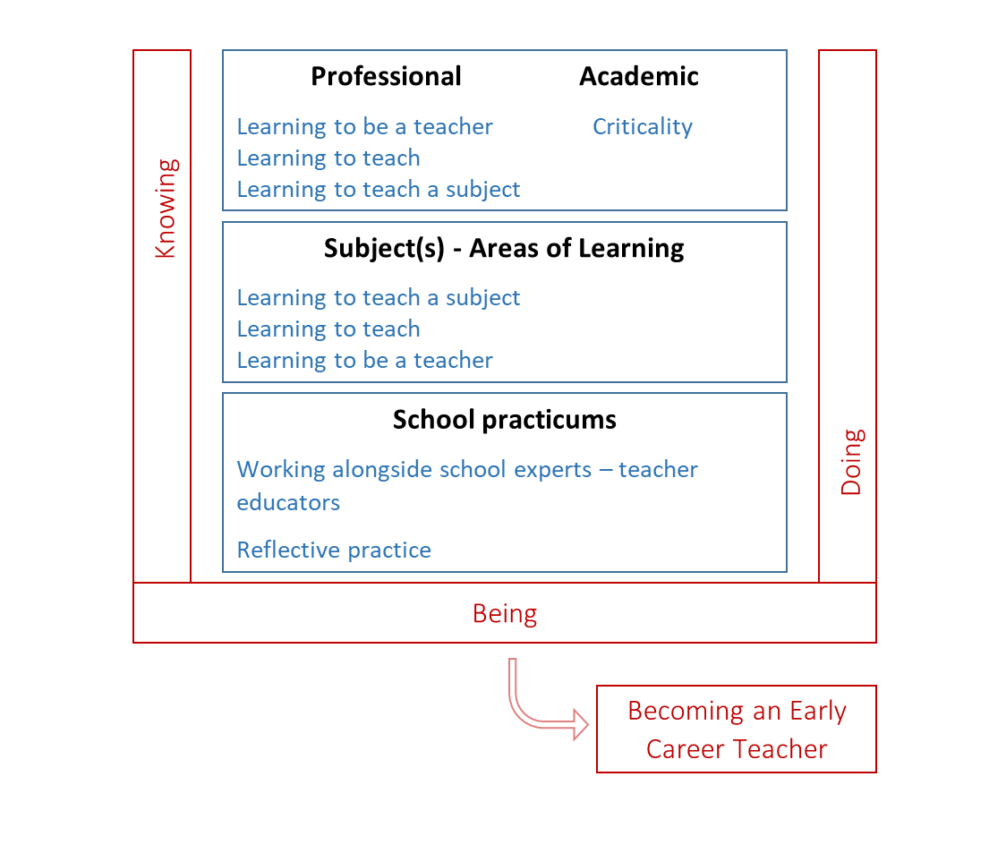We have adopted the concepts of Knowing, Doing, Being and Becoming (Craig, 2018) as a way to articulate the complex process of integrating theory and practice. This underpins our curriculum structure of taught sessions (professional, academic and subject elements) and school practicums, as outlined in the framework below (figure 1.1).

Figure 1.1 Curriculum Framework

* **Knowing** - The complex and interrelated body of knowledge for teaching and ways of thinking, such as creativity and criticality.
* **Doing** The multifaceted skills and practices involved in teaching.
* **Being** Self-awareness that establishes professional identity and responsibilities, and the reflexive relationships with others.

Approximately one third of the course is university-based, with those building blocks focussing on professional and academic issues, with an emphasis on learning to be a teacher, learning to teach, and subject specific elements with a greater emphasis on learning to teach a subject. The majority of the time on the course is spent on school practicums, where our student teachers will work alongside school experts to develop their practice. Whilst the university elements will focus more on the ‘knowing’ and school practicums encompass more ‘doing’, these interlink and will be drawn together, through reflecting upon practice, theory and research, in order to develop student teachers’ professional identity (being).

The PGCE curriculum is set within a number of regulatory frameworks from the Department for Education (DfE), Office for Standards in Education (Ofsted) and Quality Assurance Agency (QAA) for Higher Education. This course therefore draws upon:

* Experiences and expertise of tutors, Partnership schools and wider professionals
* DfE (2019) Core Curriculum Framework and DfE (2021) Early Careers Framework
* DfE (2013) Teachers’ Standards
* Ofsted (2020) Fundamental English and Maths skills
* QAA(2014) Academic skills and integrity of a Master’s level course

Our Partnership Management Groups, External Examiners, Student Staff Councils and student teachers and co-tutor evaluations also guide and support the develop and continual improvement of how our curriculum is implemented.

### Reflective Practice

Our student teachers will engage in reflective practice, which is an integral part in developing a strong professional teaching identity, and practice. The following five questions will anchor the students’ reflective practice in five key areas:

* **Relationships and Behaviour Management:** What is the role of relationships in schools?
* **Pedagogy:** What does inclusion really mean?
* **Curriculum**: Why is a broad, balanced and ambitious curriculum important?
* **Assessment:** What is your understanding of your impact on pupil progress over time?
* **Professional Behaviours:** How are you developing your teacher identity?

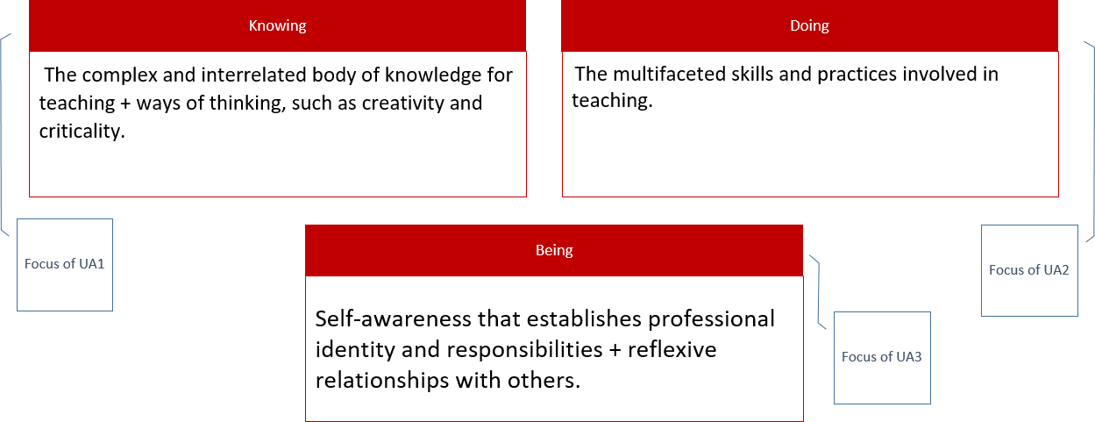As these will be revisited throughout the range of university and school based experience this will support the students to remember more, know more and do more as the course progresses.

### Key approaches for to implementation

|  |  |  |
| --- | --- | --- |
|  | **University** | **School** |
| **KNOWING: Acquiring knowledge through** | | |
| Expert Colleagues | Taught sessions by expert tutors and educational professionals  Subject and phase specificity | Observation of expert colleagues  Discussion and analysis with expert colleagues  Analysis and deconstruction of observations of expert colleague practice  Feedback from expert colleagues |
| Reading and writing | Academic books and articles  Professional sources, including journals  Statutory, policy and advisory documents  Academic assignment writing | School policy documents  School curriculum documents  School data  Planning lessons |
| Peers | Paired/Group Discussions  Online Discussion Boards | Sharing school experiences |
| **DOING: application of knowledge in an educational context and learning through experience** | | |
| Practice | Teaching your peers (Microteaching)  Scenarios | Observation and assessment of learning  Deconstruction of own teaching  Teaching small groups  Whole class teaching  Wider school life opportunities (whole staff/phase/subject meetings, parents consultation) |
| Learning from experts colleague | Acting on feedback from tutors | Acting on feedback from school based experts and university tutors  Deconstruction of observations of teaching approaches |
| **BEING: Developing teacher identity** | | |
| Reflecting | Theories and practice  Experiences of learning both in university and school | Impact on pupil progress:   * Lesson Evaluations * Weekly Reviews * Professional Development |

*Figure 1.2: Curriculum Implementation*

During the PGCE year students can achieve up to 90 Level 7 credits. Our assignments have been designed to empower students to become evidence informed practitioners as outlined in Figure 1.3.

Figure 1.3 Assignment foci

# Impact of the of the University of Leicester’s PGCE Curriculum

There are many stakeholders in our partnership, and an effective PGCE curriculum can impact our student teachers and the schools they work in, including pupils. The overarching aim is to have a positive impact on pupils’ education, both during the PGCE course and in future years. The following measures focus on the impact on student teachers which, in turn, will lead to positive outcomes for pupils.

Completion rates and attainment rates will be benchmarked against national data. Progression into employment and/or further study opportunities will be monitored. Our impact against our curriculum intentions are outlined in the table below.

|  |  |  |  |
| --- | --- | --- | --- |
| **Intention** | **Measures** | | **Impact on Student teacher** |
| **Intention 1:** **Being evidence informed practitioners** | Academic Assignments  Mentor/Co-tutor, School Feedback and Observations  End of Phase Reports  Student Evaluation  Quality Assurances:   * Internal Moderation * Student Evaluations * School Evaluations * Partnership Management Group * External Examiners | Discussions with Students | Able to make educational decisions in the best interest of the pupils. |
| **Intention 2: Having good subject and pedagogical knowledge** | Subject Knowledge Audits  Students’ Planning /Teaching | Can plan, teach and deliver an inclusive broad and balanced curriculum |
| **Intention 3: Using assessment effectively** | Students’ Planning | Can use effective assessment strategies to support all pupils’ progress. |
| **Intention 4: Developing positive relationships and behaviours for learning** | Students’ Teaching | Is responsive to pupils needs enabling them to thrive. |
| **Intention 5: Acting professionally** | Safeguarding Audit  Certificate Teacher and Law | Demonstrates appropriate professional conduct. |

### Roles and Responsibilities

**Co-Tutor:** An expert colleague and subject teacher who takes responsibility for the student teacher’s subject work within the school or college, and assesses their progress within the subject domain and against the course curriculum

**ITE Coordinator:** A senior member of the teaching staff within the school or college who has an over-arching responsibility for overseeing student teachers’ work during the school practicum. They organise induction, whole school training events for PGCE students in school and is the school's Registered Assessor for the PGCE programme. They have an important role in supporting and assessing student teachers’ progress and should be the first point of contact if issues arise which cannot be resolved in discussion with the co-tutor.

**University Tutor:** A curriculum subject specialist who is responsible for providing the taught subject sessions at the university, assessing written assignments, and moderating the assessments made by co-tutors in the subject. The University Tutor maintains an overview of progress, and is normally the link between student teachers and the academic administration

### Induction to the school/ college

**The ITE Coordinator should:**

* Provide student teachers with a Welcome/ Induction Pack.
* Provide student teachers with information about the school, the local community and the pupils
* Arrange a tour of the school.
* Check that student teachers know where things are to be found.
* Provide student teachers with a school email log in and include them in whole school communications and briefings
* Introduce student teachers to the day-to-day routines of the school.
* Inform student teachers of the school’s Safeguarding procedures.
* Inform student teachers about the school’s behaviour policy - rules, rewards and sanctions.
* Inform student teachers of marking policies
* Ensure that student teachers are fully informed about systems of provision for pupils with SEND and have access to data.
* Inform student teachers of the school's Equal Opportunities Policy.
* Provide Student teachers with information about any relevant current initiatives or legislation.
* Ensure that the student teachers have an individual place to work, and a place to meet and discuss with other student teachers
* Ensure that, for a declared need, any reasonable adjustments are made if necessary

**The co-tutor should:**

* Introduce student teachers to departmental staff, including support staff, and explain responsibilities within the department.
* Give information about departmental resources, including books, worksheets, software, practical resources, photocopying facilities, etc.
* Allocate some work, storage space and reprographic resources for the student teacher.
* Explain departmental homework policy and assessment practice.
* Give information about external exams and specifications.
* Explain departmental Schemes of Work/ Learning, including expected levels of attainment.
* Explain pupil grouping practice.
* Give information on department meetings and in-service training events.
* Discuss behaviour policy, rewards and sanctions and sources of support.
* Explain departmental provision for Special Educational Needs and Disabilities
* Discuss expectations around communication with the student teacher, including acceptable times to email

# ‘Settling in’ Report

This is a brief report sent to the university in the third week of the school practicum, by the Coordinator, to check if the student teacher has settled into their school. The Secondary PGCE office will send out a link to the Coordinator to do this.

## Phase B Practicum – Knowing More, Doing More

The table below outlines the overall structure of the curriculum trajectory. It contains the five areas related to the CCF structure plus the Academic: Postgraduate Study area, and how they align to the Core Content Framework and the Teachers’ Standards.

The focus for Phase A was ‘Setting Foundations’. In Phase B, the focus is ‘Knowing More and Doing More’.

The top section, in pink, is assessed by university tutors.

|  |  |  |  |
| --- | --- | --- | --- |
| **Our Curriculum** | **CCF Priorities** | **CCF term** | **DfE Teachers’ Standards and statements** |
| **A) Academic: Postgraduate Study** | *Links to all five other areas e.g. through developing knowing, doing, being through engagement with university assignments.* | | |
| **B) Professional Behaviours and Values** | **Professional behaviours CCF5** | Professional Behaviours | S8 Fulfil Wider Professional Responsibilities  PPC Personal and professional conduct (Part 2) |
| **C) Behaviour and Relationships** | **Behaviour management CCF1** | High Expectations  Managing Behaviour | S1 Set High Expectations  S7 Manage Behaviour Effectively |
| **D) Pedagogy** | **Pedagogy CCF2** | How Pupils Learn  Classroom practice  Adaptive Teaching | S2 Promote Good Progress  S4 Plan and Teach Well-structured Lessons  S5 Adapt Teaching |
| **E) Curriculum** | **Curriculum CCF3** | Subject and Curriculum | S3 Demonstrate Good Subject and Curriculum Knowledge |
| **F) Assessment** | **Assessment CCF4** | Assessment | S6 Make accurate and productive use of assessment |

# Review points in Phase B

Formerly, professional judgments about student teachers’ progress were made against the Teachers’ Standards. Co tutors have used their professional expertise to view these Standards through the lens of their subject and in relation to the standards expected for trainee teachers *and* the context in which they are working.

We will be drawing on co-tutors’ professional expertise to make these same judgments against the curriculum trajectory. For the Phase B reports, the Teachers’ Standards have been added to the Curriculum Areas.

For each of the five areas:

* **Interim Report**: On Track Yes/ No or Met/Not Met
* **Teaching Standards report** –**Met/ not met** and a space for brief comments
* **Final Professional Standards Report and ECT transition–** This will cover personal and professional conduct and teaching standard 8 professional duties.

This is an example of one curriculum area:

**(D) S5: Pedagogy (CCF2): Adaptive Teaching**

**Report TS2, TS4 & TS5**

|  |  |  |  |
| --- | --- | --- | --- |
| Interim report | (Reminder: Met can include ‘with support and guidance’ and ‘not necessarily consistent’) | **TS2: On Track Yes No**  **TS4: On Track Yes No TS5: On Track Yes No** | **TS2:** Met Not met  **TS4:** Met Not met  **TS5:** Met Not met |
| Final report |  | | **TS2: Met Not met**  **TS4: Met Not met**  **TS5: Met Not met** |

This table shows the review points in Phase B, when a report is sent to the university. The record is kept on the CARD (Curriculum, Assessment and Review Document)

After completing the interim report and Phase, please save as a pdf – the student teacher uploads a copy to their blackboard and the co-tutor emails the pdf to the Secondary PGCE office. Please name the file in the following way: **SURNAME First name Subject Phase B interim/final report**

|  |  |  |  |  |
| --- | --- | --- | --- | --- |
| **Review point** | **What** | **Deadline** | **Who** | **Moderation/ QA** |
| **Week 26**  **(2nd week of practicum)** | ‘Settling in’ report | Friday 28th February | Coordinator | Coordinator reports on how well the student has settled in |
| **Week 31** | Interim Phase B Report | Friday 4th March | Co-tutor | SD co-tutors to ensure that SD Lead Schools are sent a copy |
| **Week 38** | Phase B Teacher’s Standards Report | Friday 23rd May | Co-tutor | Countersigned by Coordinator; SD Mentor/Coordinators to ensure that SD Lead Schools are sent a copy |
| **Week 39** | Student Progress Review  Targeted Action Plans for identified students in need of additional support |  | University tutors | Student progress meeting |
| **Week 48** | Professional Standards and ECT report | Friday 20th June | Co-tutor |  |

# Teaching Timetable for Phase B

The expectation for Phase B is that student teachers have a timetable that represents 66% of an ECT’s teaching load. This should include a range of classes.

The first week is used for observation and preparation; gathering data and information about the classes and the student teacher might teach parts of lessons. In the second week, the student teacher can begin teaching full groups, but not all of their classes straight away. The professional judgement of the co-tutor, in discussion with the student teacher, will inform decisions about this, but it is expected that by Course Week 23 (3rd week in school) most student teachers will have taken on all their timetabled classes. This ‘soft start’ is intended to allow the student teacher to take on more classes as their confidence grows.

**Year 11**

Year 11 planning and teaching needs to be included, if the school has Year 11. This does not need to be all of the class’s lessons and can be a combination of team-teaching, small group interventions or part of the lesson. However, the student teacher needs to plan and evaluate their teaching, just as they do for groups that they teach all the time.

**Post 16**

Post 16 teaching should also be timetabled, if the school has a 6th form. This can be a flexible combination of teaching one lesson per week, additional lessons at lunchtime, intervention with small groups and team teaching. Evidence of planning and evaluation needs to be shown. If a student teacher needs post 16 experience, and this is not possible in either placement school, alternative arrangements will be made.

**PSHE**

It is expected that student teachers will be involved in teaching the PSHE curriculum; this will be in addition to their subject teaching. This is likely to be one lesson per week supporting a teacher in Phase A and leading the teaching of PSHE for one lesson a week in Phase B.

**Pastoral role**

Student teachers shadowed a form tutor during Phase A. In Phase B they need to work with a tutor group, so that they are prepared for this role in their ECT year

A guide to how many teaching hours based on number of lessons in your school is below:

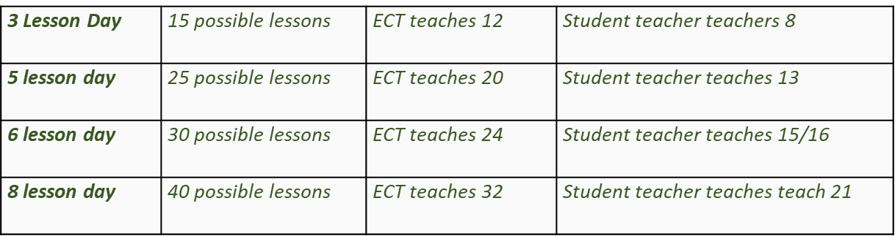

# CARD (Curriculum, Assessment and Review Document)

There is a version for Phase A and another for Phase B

It is the key document which tracks the student teacher’s progress against our curriculum.

It replaces the separate Interim and Phase report documents and the old tracking document

It is organised into the 5 curriculum areas:

1. Academic: Postgraduate Study
2. Professional Behaviours and Values (including CCF5): Learning to be a Teacher
3. Behaviour and Relationships (including CCF1): Learning to Teach and Learning to Teach a Subject
4. Pedagogy (including CCF2): Learning to Teach and Learning to Teach a Subject
5. Curriculum (including CCF3): Learning to Teach and Learning to Teach a Subject
6. Assessment (including CCF4): Learning to Teach and Learning to Teach a Subject

Assessment will be based on the professional judgement of co-tutors, supported by Coordinators, benchmarked by CARD statements in each curriculum area, with some subject specific exemplification. As previously, these judgements will draw on observations, professional dialogue and other teaching-related activities. During weekly meetings and when university tutors visit, the Talkthrus will be addressed, which will draw out key aspects of the student’s understanding.

# Focused Observations/ Focused Activities

Lesson observations by the student teacher, of expert colleagues, is an expectation throughout both school practicums. One focused observation per week, or a focused activity, is expected, with a record kept by the student teacher. There is a prompt provided for each week in the Phase B practicum and these are linked to the themes in the Master prompts

Observing other teachers’ lessons is harder than it looks. It is important for student teachers to distinguish between classroom activity and their interpretation of that activity (which will draw on models of learning). The focus given is deliberately narrow, to allow you to look closely at a specific aspect of the classroom. It is important to write in as much detail as possible when observing the lesson, then review and deconstruct with an expert colleague (this can be the co-tutor or a class teacher)

**It is essential that observation protocols are discussed before a student teacher observes an expert colleague’s lesson**

# ERF (Evidence Record Form)

This form is used to record observations of the student teacher’s teaching. It can be used for whole lesson observations, or to focus on a specific aspect of teaching.

It is expected that one formal lesson observation per week be done during the school practicum (and every class that the student teacher teaches must be observed once).

Observations can be undertaken by the co-tutor or an expert colleague (the class teacher) but it is important that the co-tutor communicate with any other expert colleague about agreed current targets and priorities, so that the student teacher is not overloaded.

# Student Reflections/ Weekly emails to student teachers and co-tutors

Student Reflections were begun by student teachers in Week 1 of the course. These are prompted by questions linked to key reading.

During the school practicums, student teacher continue to reflect; Student Reflections are prompted by the Weekly Focus and are linked to our curriculum. A weekly email to student teachers and co-tutors from the university provides these prompts.

# Weekly Meetings

It is essential that student teachers prepare for the weekly meetings by thinking through in advance their responses to Student Reflection prompt questions and Talkthus

Some of the weekly meeting will need to be used for discussion of lesson planning and feedback from observations etc; it is suggested that half the meeting is devoted to this and half to the weekly focus.

## Blackboard and Eportfolio

Student teachers are responsible for keeping all their records up to date in their Eportfolio on their university OneDrive. Some of these records should be uploaded each week onto blackboard. **This is a course requirement.**

During school practicums, student teachers will be uploading their lesson plans, evaluations/ reviews, ERFs (Evidence Record Forms), Weekly Meeting Record and their CARD (Curriculum, Assessment and Review Document) to Blackboard.

## University Tutor QA/ Moderation Visits

**University- led (Core) student teachers:** Each student teacher is normally visited ONCE per placement by their University tutor.

As part of Quality Assurance, each visit will include:

* a discussion of the student teacher’s progress against the curriculum benchmarks (CARD) and, if appropriate, a Talkthru
* a discussion of current targets

The student teacher must have the relevant files in their portfolio up to date at the time of this visit, to include:

* Lesson plans, reviews/ evaluations
* ERFs
* Weekly Meeting Record
* CARD (Curriculum, Assessment and Review Document)

**Lead Partner Students:** The Lead school will arrange visits to each student teacher. A university tutor will visit each lead school as part of the QA arrangements.

## Support Plan/Action Plan

A cause for concern can be raised by a University tutor, ITE Coordinator or co-tutor **at any stage in the course and when any aspect of a student teacher's work gives rise to doubts about their ability to proceed to QTS.** If a student teacher is School Direct, the Lead Alliance Coordinator/ Director must be the first point of contact.

A Support Plan should identify specific targets for the student teacher to achieve by a set date and to be shared with ALL parties (University, ITE Coordinators – school and Lead, student teacher). In all cases, please share with the University via secondary.pgce@le.ac.uk. And [headsec@le.ac.uk](mailto:headsec@le.ac.uk)

The Support Plan and Action Plan proforma can be downloaded from the school experience website.

## Commendation

A commendation form can be completed by a University tutor, ITE Coordinator, co-tutor or any other member of partnership staff to formally acknowledge outstanding performance by student teachers. These forms are intended to record exceptional performance, significant progress or times when a student teacher has made a notable contribution to an aspect of the PGCE course or an event held in a partnership school. Commendations are discussed by our Panel of Examiners, and formal letters sent to student teachers congratulating them on their success.

A completed commendation form should be emailed to [secondary.pgce@le.ac.uk](mailto:secondary.pgce@le.ac.uk).

The Commendation form can be downloaded from Blackboard

## Attendance

During school practicums, student teachers should inform the school of any planned or unplanned absence using the school’s normal procedures, and must inform the university, via the Secondary PGCE office.

## Staff List and Key Contacts

|  |  |  |
| --- | --- | --- |
| Name | Role | Email |
| Professor Chris Wilkins | Head of School of Education | caw11@le.ac.uk |
| Jenny Bosworth | Director of ITE | Jb591@le.ac.uk |
| Dr Jake Halford | Co-Head of Course, History and RE Subject Tutor | Jjsh2@le.ac.uk |
| Stephanie Oswald | Co-Head of Course, Modern Languages Subject Tutor | sio1@le.ac.uk |
| Sheila Dennis | English Subject Tutor | sd386@le.ac.uk |
| Kerry Onyejekwe | Social Science and Humanities Tutor | kao1@le.ac.uk |
| Dr Fay Baldry | Mathematics Subject Tutor | fb128@le.ac.uk |
| Dr Jon Heywood | Science Subject Tutor | jh407@le.ac.uk |
| Shaakirah Kasuji | Geography Subject Tutor (school based) | sk1012@le.ac.uk |
| Kerry Onyejekwe | Social Science and Humanities Tutor | kao1@le.ac.uk |
| Adrian Warhurst | Science Subject Tutor | agw13@le.ac.uk |
| Dr David Wharton | English Subject Tutor | dw199@le.ac.uk |
| Dan Lathbury | PGCE Partnership Office | pgce.partnership@le.ac.uk |
| Patrick Dudley | Programme Administrator, Secondary PGCE | secpgce@le.ac.uk |

## Course Calendar 2024-25

Please note: Whilst in school student teachers follow their school’s holiday pattern (swapping in school days with study days as needed). School holiday patterns do vary – student teachers are expected to check this as soon as they know your placements. (For those on 5 term patterns they may need to discuss this with their co-tutor).

|  |  |  |  |  |  |
| --- | --- | --- | --- | --- | --- |
| On Campus | In school (school practicums) | Study days | Holiday – University open | Holiday – University closed | School Terms |

Key:

Phase B

|  |  |  |  |  |  |  |  |
| --- | --- | --- | --- | --- | --- | --- | --- |
| 10/02/2025 | 24 | 30 | 10/02 | 11/02 | 12/02 | 13/02 | 14/02 |
| 17/02/2025 | 25 | 31 | 17/02 | 18/02 | 19/02 | 20/02 | 21/02 |
| 24/02/2025 | 26 | 32 | 2 24/02 | 25/02 | 26/02 | 27/02 | 28/02  Settling in Report |
| 03/03/2025 | 27 | 33 | 3 03/03 | 04/03 | 05/03 | 06/03 | 07/03 |
| 10/03/2025 | 28 | 34 | 4 10/03 | 11/03 | 12/03 | 13/03 | 14/03 |
| 17/03/2025 | 29 | 35 | 5 17/03 | 18/03 | 19/03 | 20/03 | 21/03 Return Day  UA3 PT2 |
| 24/03/2025 | 30 | 36 | 6 24/03 | 25/03 | 26/03 | 27/03 | 28/03 |
| 31/03/2025 | 31 | 37 | 7 31/03 | 01/04 | 02/04 | 03/04 | 04/04  Interim Report |
| 07/04/2025 | 32 | 38 | 8 07/04 | 08/04 | 09/04 | 10/04 | 11/04 |
| 14/04/2025 | 33 | 39 | 14/04 | 15/04 | 16/04 | 17/04 UoL: Closure Day | 18/04 Bank Holiday: Good Friday |
| 21/04/2025 | 34 | 40 | 21/04 Bank Holiday: Easter Monday | 22/04 UoL: Closure Day | 23/04 UoL: Closure Day | 24/04 | 25/04 |
| 28/04/2025 | 35 | 41 | 9 28/04 | 29/04 | 30/04 | 01/05 | 02/15 |
| 05/05/2025 | 36 | 42 | 05/05 Bank Holiday | 10 06/05 | 07/05 | 08/05 | 09/05 |
| 12/05/2025 | 37 | 43 | 11 12/05 | 13/05 | 14/05 | 15/05 | 16/05 |
| 19/05/2025 | 38 | 44 | 12 19/05 | 20/05 | 21/05 | 22/05 | 23/05 Teachers’ Standards Report |
| 26/05/2025 | 39 | 45 | 26/05 Bank Holiday | 27/05 Return Day  ECT + subject day | 28/05 (Writing ECT transition document) | 29/05 | 30/05 |
| 02/06/2025 | 40 | 46 | 13 02/06 | 03/06  Dev day/ PMG 23-24 | 04/06 | 05/06 | 06/06 |
| 09/06/2025 | 41 | 47 | 14 09/06 | 10/06 | 11/06 | 12/06 | 13/06 |
| 16/06/2025 | 42 | 48 | 15 16/06 | 17/06 | 18/06 | 19/06 | 20/06 Professional Standards + ECT report |
| 23/06/2025 | 43 | 49 | 16 23/06 | 24/06 Student progress meeting | 25/06 | 26/06 | 27/06  PGCE: Last Day |