# Curriculum Assessment and Review Document (CARD): Phase 1

|  |  |  |  |
| --- | --- | --- | --- |
| **Name: Trainee Teacher** | **Name: Teacher Mentor** | **School** | **Year group** |
|  |  |  |  |

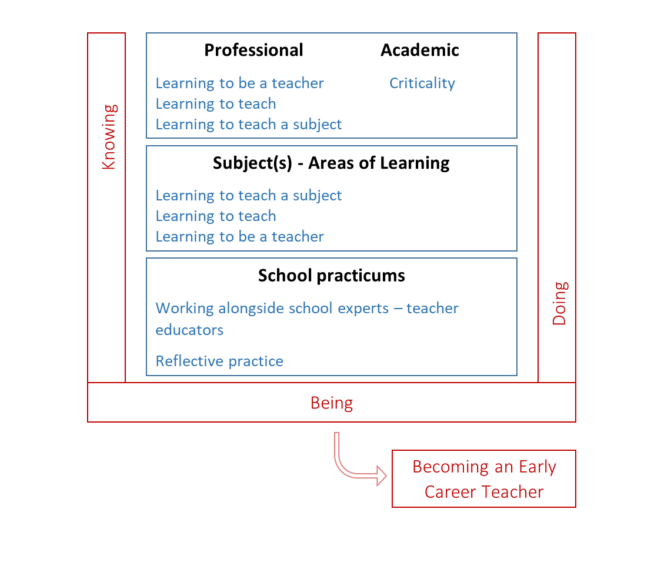We have adopted the concepts of Knowing, Doing, Being and Becoming (Craig, 2018) as a way to articulate the complex process of integrating theory and practice. This underpins our curriculum structure of taught sessions (professional, academic and subject elements) and school practicums, as outlined in the framework below.

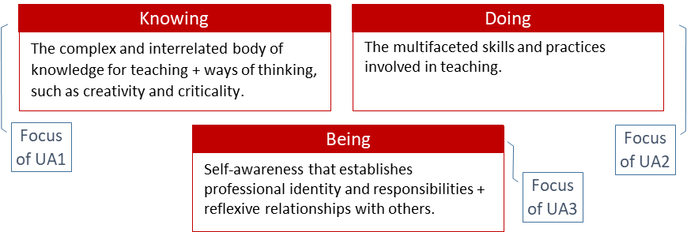

The CCF is the government specified minimum curriculum entitlement; it is embedded throughout the course.

The CCF is structured in five **areas** and is related to the Teachers’ Standards (S1-8 plus Part 2) as per the table; our curriculum, outlined in this document, adopts the same overall structure. Trainees are assessed against the Teachers’ Standards at the end of the course; this document, CARD, provides the benchmark statements against which their progress is formatively assessed during phase A.

## Phase 1 placement – Setting the foundations

Prior to 2021, professional judgments about trainees’ progress have been made against the Teachers’ Standards. You have used your professional expertise to make judgments through the lens of your subject, and in relation to the progress expected for trainee teachers *and* the context in which they are working. We will be drawing on your professional expertise to make these same judgments against our curriculum, as summarised in our benchmark statements here in CARD A. The statements are what a trainee should ‘look like’ at the end of Phase 1, rather than the end of the course.

## Curriculum Structure: Overview Phase 1 placement – Setting the foundations

The table below outlines the overall structure of the curriculum trajectory. It contains the **5 areas** related to the CCF structure plus the Academic: Postgraduate Study area.

The Themes and Focus provide the headlines for the curriculum for Phase 1; further details of the curriculum will be discussed at the Teacher Educator Development meeting, and supporting documentation will be available on Blackboard.

The Knowing and Doing provide the highlights of this ‘Setting the Foundation’ phase, and are expanded upon over the subsequent pages. More of the Knowing benchmark statements are orange, and will be assessed through university assessments. We are asking you to focus on the green boxes, which are mainly, but not exclusively, the Doing statements; we appreciate there is much interdependency. (Academic: Postgraduate Study, relates to academic assignments - assessed by university tutors).

|  |  |  |  |  |
| --- | --- | --- | --- | --- |
| **Theme** | **Focus for Phase 1** | **Knowing** | **Doing** | Review |
| Academic: Postgraduate Study | | | | |
| Postgraduate Responsibilities | Integrity | Academic conventions | Accurate referencing | UA1 |
| Research Literate | Criticality | Synthesis and analysis | Critique practice using evidence | UA1 |
| Professional Behaviours and Values (including CCF5) | | | | |
| Reflective Practice | Reflection⇨ developing practice | Models of reflection | Weekly meetings | CARD 1 |
| Professional Behaviours (S8) | Professionalism, keeping children safe | PPC | Ongoing esp. in school | CARD 1 |
| Beliefs and Values | Identity, expectations | Impact of expectations | Use appropriate language | CARD 1 |
| Behaviour and Relationships (including CCF1) | | | | |
| Behaviour Management (S7) | Routines, de-escalation/restoration | Role of routines | Consistency | CARD 1 |
| Learning Environment (S1) | Relationships, classroom norms | Role of mutual respect | High expectations | CARD 1 |
| Pedagogy (including CCF2) | | | | |
| How children learn (S2) | Schools of thought (learning, pedagogy) | Main theories | Relate to practice | CARD 1 |
| Planning (S4) | Sequencing learning opportunities | Key features of lessons | Sequence lessons with support | CARD 1 |
| Adaptive Teaching (S5) | Inclusion, inc. SEND, SES, PP EAL | Principles of inclusion | Adapt lessons with support | CARD 1 |
| Curriculum (including CCF3) | | | | |
| Subject Curriculum (S3) | Subject and pedagogical content knowledge | Key subject concepts | Use good examples, models | CARD 1 |
| Curriculum (S3) | Curriculum knowledge and design | Statutory guidance | Engage with school curriculum | CARD 1 |
| (F) Assessment (including CCF4): Learning to Teach and Learning to Teach a Subject | | | | |
| Assessment (S6) | Summative and formative assessment | Types of assessment | Plan for assessment | CARD 1 |

#### Supporting Development

Whilst the CARD provides the structure for the interim and final reports, its key function is developmental. It provides a framework for the trainees and yourselves to understand their curriculum and map out an appropriate developmental trajectory.

Language: We have used language such as ‘aware’ to indicate that the trainees are expected to have some understanding of the role issues may play in learning and teaching, but understanding is unlikely to be fully formed at this ‘setting the foundations’ stage of the course.

#### Assessment

Your assessment will draw on a range of evidence:

Observations of trainees’ lessons, professional dialogue and other professional activities outside of lessons.

Professional dialogues will allow trainees to articulate their understanding; Talk-throughs offer a focus for *some* of these discussions of key issues.

|  |  |
| --- | --- |
| Seek, reflect and act on feedback from experts.  **Use reflection to develop practice** | **Final**: Secure Yes Not yet |
| [Engage with school policies and practices] |  |

CARD outlines the main curriculum themes and foci. We are asking you to assess the student teacher against key benchmark statements – highlighted in **green** – playing particular attention to the **bold**.

To be read with a preface of ***“The trainee is able to…***” or similar.

|  |
| --- |
| Reflect on beliefs and values |

There are also some statements written in [brackets]. These are likely to part of the student teacher’s experiences but are not central to the assessment of this phase. You may add comments if appropriate and you wish to do so.

The orange boxes relate to elements that will be assessed through university-based activities in this phase, such as written assignments.

This one CARD is used throughout the placement; for reporting **you fill in the white boxes on pages 4-10,** covering Fundamental English and Mathematics and (B) to (F).

For each key benchmark statement:

Safeguarding - secure yes/no for both reports; Part 2 and fundamental English/mathematics– met/not met for both reports.

**Final** report – Final **Secure** is your professional judgement in relation to the statement(s) in green, which have been written to articulate what would be expected at this stage of the course (not the standard expected at the end of the course).

For each of the **five areas**

Final report – **Overall: On track** is a ‘**best fit**’ for that **area** to indicate whether the trainee has made progress that would put them on a trajectory to be able to successfully compete the course (meeting that Teachers’ Standards in phase 3)– they are **not** expected to be secure in all areas. In this phase, the trainees are not expected to demonstrate all skills independently; If “the trainee is able to… *with appropriate support and guidance*” they meet ‘secure’ at this stage of the course. It is important to note that the PGCE year, forms part of a three-year programme. Consequently, the assessments made within this document are commensurate with the developmental stage of the trainee. (All areas except (D) are on a single page - (D) Pedagogy statements are split over two pages with the one Overall: On track decision on the *first* page)

After completing the interim and final report please save as a pdf and email to [pripgce@le.ac.uk](mailto:pripgce@le.ac.uk). The student teacher should upload the pdf to their e-Portfolio.

File Name: **SURNAME First name CARD Phase 1 (Final)**

## Fundamental English and mathematics

Prior to the award of QTS trainees need to demonstrate competence in the following areas. If there are any ‘Not Met’ please provide brief details.

|  |  |  |
| --- | --- | --- |
| **Spoken English**: Use standard English grammar, with clear pronunciation and vocabulary relevant to the situation to convey instructions, questions, information, concepts and ideas with clarity. | Final: Met Not Met | Details if ‘Not Met’: |
| **Written English:** Write clearly, accurately, legibly and coherently using correct spelling and punctuation. Read fluently and with good understanding. | Final: Met Not Met | Details if ‘Not Met’: |
| **Mathematics:** Able to interpret children’s data as appropriate, able to complete relevant calculations fluently (whole numbers, fractions, decimals and percentages). | Final: Met Not Met | Details if ‘Not Met’: |

## Academic: Postgraduate Study

This section is assessed by university tutors and is here for reference.

|  |  |  |  |  |
| --- | --- | --- | --- | --- |
| **Theme** | **Focus** | **Knowing** (knowledge, skills and understanding) | **Doing** | **Review** |
| Postgraduate Responsibilities | Course Engagement | How the PGCE and QTS relate | Engage with all elements, inc. student reflections | Tutorials |
| **Academic Integrity (plagiarism)** | **Academic conventions** and protocols | Reference accurately, represent people fairly | UA1 |
|  |  |  |  |  |
| Academic Reading and Writing  Research Literate | **Criticality** | Demonstrate synthesis and analysis from a **critical stance.** | Critique practice using evidence | UA1 |
| Critical Reading | Identify sources, interrogate evidence; consider substance and relevance of sources | Draw on academic reading to inform and interrogate classroom practice. | UA1; (Talk-throughs, focussed observations, reflections) |
| Critical Writing | Demonstrate synthesis and analysis, considering alternative perspectives | Draw on school experiences to inform academic writing, and for writing to inform practice. | UA1 |
| Research in Education | Aware of the role of research in education, appreciating the complexities inherent in understanding classrooms | Interrogate the links between theory and practice, and the implications of ‘evidence informed practice’ | UA1; (Talk-throughs, focussed observations, reflections) |
| Reflexivity | Reflection and Beyond | Understand that one’s own beliefs and what one ‘takes for granted’ influences research and professional development | Consider positionality as a practitioner and researcher, seeking to challenge own assumptions. | Reflections (inc. weekly meetings), UA1 |

## Professional Behaviours and Values: CCF5

|  |  |  |  |  |  |
| --- | --- | --- | --- | --- | --- |
|  | **Focus** | **Knowing** (knowledge, skills and understanding) | **Doing** | | Review Points |
| **Ref** | **Reflection** | Understand and apply Brookfield’s lenses (2005) as a model of reflection; be aware that reflection develops practice, especially when supported by observation of and feedback from experts. | Seek, reflect and act on feedback from experts.  **To use Brookfield’s model of reflection (2005) to develop practice** | | **Final**: Secure Yes Not yet |
| **Professional Behaviours** | **Professional Conduct** | Understand what behaviours are compatible with the teaching profession, (PPC) and that a teacher is expected to demonstrate consistently high standards of personal and professional conduct. | **Maintain professional behaviours** (PPC)  inc. professional relationships with tutors, colleagues and peers  Responds positively, constructively and quickly to feedback and communication.  Be proactive in raising any areas of concern or development. | | **Final**: Met  Not Met |
| Self- management | Aware of strategies for managing workload, mindful of work/life balance and well-being, knowing expert support is essential. | Organise time and workload, to support your wellbeing and work/life balance, through protecting time for rest and recovery.  Be proactive in keeping documentation up to date.  Seek support and guidance from experts if needed to develop. organisational skills. | | **Final**: Secure Yes Not yet |
| The Teacher and the Law | Teachers are expected to engage with key regulatory/legal and advisory frameworks (e.g. Children and Families Act 2014, Equality Act 2010). | Act within appropriate frameworks and policies | | **Final**: Met  Not Met |
| **Keeping Children Safe** | Know teachers have responsibility to **keep children safe** from harm, understanding safeguarding, knowing indicators of harm, including how to support children to keep safe on line. | Adhere to school **safeguarding polices** and report concerns immediately through the processes of your placement school. | | **Final**: Secure Yes Not yet |
| Wellbeing | Be aware of mental health and well-being issues (children) | Engage with school policies and practices | |  |
| **Beliefs and Values** | **Identity** | Know that teachers' beliefs and values impact on practice. | Reflect on own beliefs and values through your weekly review forms. | | **Final**: Secure Yes Not yet |
| Teachers’ **Expectations**  and Influence | Know that teachers can influence attitudes, wellbeing, motivation and behaviour of children, with **expectations** influencing outcomes. Know that language and behaviours are key to communicating expectations. | Identify appropriate language and behaviours to communicate **unconditional positive regards** through a belief in **the potential of all children**; with expert guidance, practice use. | | **Final**: Secure Yes Not yet |
| Purpose of Education | Be aware of different perspectives on the role of education (e.g. cultural, economic) and the impact on individuals and society. | Understand the school's ethos and articulate how this is expressed.  Complete the context and curriculum task in the first task. | |  |
| Social Justice | Be aware societal inequities can be impacted by education. | To articulate the development of your understanding of pupil premium as a system for supporting disadvantaged groups of learners. | |  |
| Inclusion (EDI) | Know all children are entitled to receive high quality teaching. | As a trainee teacher you uphold the roles and responsibilities of the teacher, so that all children make progress in their learning. | |  |
| Final report | | Comment: | | | **Part 2: Met  Not Met**  **On Track: Yes No** |
| Strengths: | | Areas for development: | |

## **Behaviour and Relationships**: **CCF1**

|  |  |  |  |  |  |
| --- | --- | --- | --- | --- | --- |
|  | **Focus** | **Knowing** (knowledge, skills and understanding) | **Doing** | | **Review** |
| **High Expectations** | Relationship Building  C10 | Understand how a culture of **mutual respect** influences the learning environment. | Establish professional and positive relationships with children and adults – within your placement class and the wider school. | | **Final**: Secure Yes Not yet |
| **Expectations**  Classroom norms  Engagement | Be aware many expectations are established and communicated implicitly through classroom norms. | To observe and enact strategies demonstrated by your teacher mentor that reinforce classroom norms. | | **Final**: Secure Yes Not yet |
| Positive learning environment    C14 | Be aware that a positive learning environment has physical and emotional elements. | With appropriate supervision and guidance, maintain a positive learning environment for children. | | **Final**: Secure Yes Not yet |
| Understanding Oneself | Know teachers' behaviours influence children, so regulating oneself is essential. | Modelling and expecting positive attitudes and behaviours, from yourself and the children. | | **Final**: Secure Yes Not yet |
| **Managing Behaviour** | Behaviour for Learning  **Expectations**  3Rs | Know classroom behaviours impact on the learning environment. Aware of the role of **high expectations** and the 3Rs, ‘routines, relationships and responses’, in creating a positive learning environment and how this might be achieved. | Follow your school’s behaviour policy, aiming for **consistency** in responses to children behaviour.  Observe and plan for classroom **routines**, inc. consistent use of language and non-verbal signals that should communicate **high expectations**. | | **Final**: Secure Yes Not yet |
| Responses  De-escalation and restorative practices | Be aware that consistency of responses is important and requires practice (praise, sanction and reward strategies, inc. low-level interventions, de-escalation and restorative practices). | With support (e.g., real time feedback) seek opportunities to practice and develop consistency; respond to low-level disruptions, apply de-escalation and restorative practices (subject to school policies). | | **Final**: Secure Yes Not yet |
| Motivation  Tasks | Understand motivation is complex, informed by a range of theoretical perspectives. | Identify strategies that expert colleagues use to motivate children and keep them on task.  Observe and reflect upon tasks that are designed to motivate learners. | | **Final**: Secure Yes Not yet |
| Final report | | Comment: | | | **On Track: Yes No** | |
| Strengths: | | Areas for development: | | |

## Pedagogy: CCF2

|  |  |  |  |  |  |  |
| --- | --- | --- | --- | --- | --- | --- |
|  | **Focus** | **Knowing** (knowledge, skills and understanding) | **Doing** | | **Subject context** | **Review** |
| **How children learn** | Theories of learning | Know there are different schools of thought about learning and understand the key tenets of:  cognitive/neuroscience, constructivism, social-constructivism, humanism, behaviourism | Articulate how particular perspectives inform:   1. interpretation of classroom observations 2. planninga session   (e.g., (i) interpreting learning through the lens of social-constructivism, (ii) utilising peer talk when planning a lesson) | | e.g., CLT within Phonics programmes, social constructivism in paired talk, behaviourist approaches to managing classroom transitions. | **Final**: Secure Yes Not yet |
| Cognitive Science | Aware of cognitive science perspectives, including CCF endorsed approaches:  Mental schema: influence of prior knowledge.  Memory: working (limited capacity) and long-term.  Cognitive Load (CLT):  dual coding, worked examples, retrieval, spaced learning, practice… | Engage with school approaches related to cognitive science  Relate particular perspectives to practice:   1. planning of single lessons 2. interpretation of lesson observations.   Discuss concept/schema formation (inc. how to identify/address misconceptions) | | Understanding the reading process – importance of prior knowledge in building mental schema.  Importance of dual coding within mathematics. | **Final**: Secure Yes Not yet |
| Pedagogical approaches | Awareness of different schools of thought about theories of learning and their links to pedagogy. | Able to identify pedagogical approaches within TM’s lessons and can, with support, use these approaches when teaching.  ITP 1 – Articulate your understanding of how theories of learning provide frameworks for understanding deployed pedagogical approaches. | | e.g., Taking account of prior learning and introducing new material to manage cognitive load. | **Final**: Secure Yes Not yet |
| Final report | | Comment (this includes the next page): | | | | This includes the next page  **Overall: On Track Yes No** |
| Strengths (this includes the next page): | | Areas for development (includes the next page): | | |

## Pedagogy – part 2: CCF2

|  |  |  |  |  |  |  |
| --- | --- | --- | --- | --- | --- | --- |
|  | **Focus** | **Knowing** | **Doing** | | **Subject Context** | **Review** |
| **Classroom Practice** | Lesson planning | **Understand key features of lessons,** and how different types of activities can be selected and organised e.g., retrieval, exposition, rehearsal, practise. | Plan lessons for a class or small group (drawing on school planning documents, or schemes of work)  Over time, use a range of activities,  With expert support analyse/ deconstruct the possible implications for children learning. | | All mathematical tasks given to children **must** be completed by the student teacher beforehand (identifying links to concepts, considering representations and misconceptions)  Recognise that lessons will look different in different subject areas and year groups. | **Final**: Secure Yes Not yet |
| Sequencing | Effective teachers introduce new materials in steps, explicitly linking new ideas to what has previously been studied. | To discuss sequencing with your teacher mentor to develop your understanding of planning that builds on prior knowledge and the ordering of developmental steps within a lesson. | | Within a science topic of light, to recap the sources of light before progressing to learn about light in straight lines; within the structure of retrieval, stimulus, exploration and plenary. | **Final**: Secure Yes Not yet |
| Modelling | To know that modelling helps pupils learn new processes and ideas. | When modelling, narrate your thought process to make explicit how experts think. | | When modelling writing, as you scribe your ideas, articulate your reasoning about vocabulary choices and authorial decisions. | **Final**: Secure Yes Not yet |
| Teaching and learning cycle | To understand the teaching and learning cycle, from a range of perspectives e.g., Brookfield’s lenses.  To know that you, when teaching, are the key agent within this cycle, with the responsibility to influence the pupil progress. | Able to evaluate pupil progress and plan for next steps in the children’s learning. | | When evaluating lessons, recognise the impact of your teaching on pupil progress and reflect on the effectiveness of strategies used. Evaluate each lesson and act on feedback or own reflection. | **Final**: Secure Yes Not yet |
| **Adaptive Teaching** | Development | Aware of theories of child development | Consider how your TM uses this | |  |  |
| **Inclusion** | **Principle**: Include all learners, with high expectations for all. Aware learners have different needs/support.  Aware we can make incorrect assumptions, which can lead to lower expectations for some  children. | Through discussion, identify how your teacher mentor uses strategies that enable children to succeed, by supporting their needs (e.g., EAL or SEND). | | The utilisation of a behaviour management strategy that motivates a child with a complex behaviour profile to engage in learning. | **Final**: Secure Yes Not yet |
| SEND | Aware of the key principles in SEND Code of Practice (CoP) | Deconstruct lessons and identifying the support strategies employed to adapt teaching for children with SEND. | |  | **Final**: Secure Yes Not yet |
| Responsive grouping | To understand that adapting teaching by grouping children flexibly is likely to improve pupils’ success. | To discuss your mentor’s rationale for class organisation to improve pupil success. | |  |
| Final report | | Comment: | | | | **Overall: On Track Yes No** |
| Strengths: | | Areas for development: | | |

## Curriculum: CCF3

|  |  |  |  |  |  |  |
| --- | --- | --- | --- | --- | --- | --- |
|  | **Focus** | **Knowing** | **Doing** | | **Subject Context** | **Review** |
| **Subject and Curriculum** | Subject knowledge | Understand that teachers need to have a secure subject knowledge and be proactive in developing this. | Ensure that the appropriate subject knowledge is in place for taught lessons. | |  | **Final**: Secure Yes Not yet |
| Teacher Knowledge | Understand the interconnected nature of knowledge required for teaching: subject, pedagogical content, curriculum. | Be able to recognise and identify these three elements within teacher mentor lessons/planning. | |  | **Final**: Secure Yes Not yet |
| Pedagogical content knowledge | Identify **key concepts,** ideas, knowledge, skills and principles of the subject. | Identify these models within your teacher mentor’s planning and lessons.  Assess focus children using the SVoR. | | e.g., SVoR in reading and the rope model in mathematics. | **Final**: Secure Yes Not yet |
| Language. literacy and numeracy | Understand how literacy supports learning across the curriculum.  To understand the importance of metalanguage within subjects (e.g., Split digraph in phonics or addend in mathematics). | Model subject-specific language and have high expectations for children’s use of high-quality language.  With support is beginning to teach/team teach SSP. | |  | **Final**: Secure Yes Not yet |
| Final report | | Comment: | | | | **Overall: On Track Yes No** |
| Strengths: | | Areas for development: | | |

## Assessment: CCF4

|  |  |  |  |  |  |  |
| --- | --- | --- | --- | --- | --- | --- |
|  | **Focus** | **Knowing** | **Doing** | | **Subject Context** | **Review** |
| Assessment | Types of Assessment  Assessment of/for Learning | Understand types and purposes of assessment:  **Formative:** Assessment for Learning (AfL)  **Summative**: Assessment of Learning (AoL)  Aware of how assessment is conducted in schools and how the information generated might be used. | Understand how your teacher mentors use AfL to identify prior knowledge/ gaps/misconceptions and begin to plan for its use.  Begin to apply this within your own practice.  Discuss how assessments – as part of the teaching and learning cycle – can inform planning and teaching; before, between and within lessons. | |  | **Final**: Secure Yes Not yet |
| Classroom assessment strategies | How assessment strategies can inform teaching and support learning.  Aware of a range of classroom assessment strategies:  (e.g., listening to paired talk, questioning, professional noticing, self/peer assessment, mini-whiteboards) | Through observation, identify formative assessment strategies and enact these. | | e.g., the use of questioning in the classroom using whiteboards… | **Final**: Secure Yes Not yet |
| Feedback  Self-regulation | Aware of a range of feedback strategies  (e.g., written, verbal…)  Understand how the principles of metacognition can be utilised to enable children to monitor and regulate their own learning. | Observe how experts and teacher mentors give feedback in line with the school’s marking policy.  Begin to provide feedback to children during lessons. | | e.g., live marking. | **Final**: Secure Yes Not yet |
| Final report | | Comment: | | | | **Overall: On Track Yes No** |
| Strengths: | | Areas for development: | | |

**Trainee’s experiences during Phase 1**

|  |  |  |
| --- | --- | --- |
|  | Observed in P1 | Taught in P1 |
| Art and Design |  |  |
| Computing |  |  |
| Design Technology |  |  |
| Geography |  |  |
| History |  |  |
| Modern Foreign Languages |  |  |
| Music |  |  |
| Physical Education |  |  |
| PSHE/RHE |  |  |
| Religious Education |  |  |

# Final Report: Overview

|  |  |
| --- | --- |
| Comment by senior leader |  |
| Signature and Date |  |

## Trainee’s response to the Final Report

|  |  |
| --- | --- |
| Trainee: Response to the final report | Comment: |
| Signature and date |  |
| Final checks | Have you named the file: **SURNAME First name CARD Phase 1 (Final)** Yes  Have you uploaded the pdf and Word version to your E-Portfolio Yes  Has the pdf been emailed to [pripgce@le.ac.uk](mailto:pripgce@le.ac.uk) Yes |