
School of Education
School Practicum Handbook
Phase A
October 2025- December 2025

Table of Contents
Welcome and Introduction 2
Intentions of the University of Leicester’s PGCE curriculum 2
Implementation of the University of Leicester’s PGCE Curriculum 3
Impact of the of the University of Leicester’s PGCE Curriculum 6
‘Settling in’ Report 8
Phase A Practicum – Setting the Foundations 8
Review points in Phase A 8
Teaching Timetable for Phase A 9
CARD (Curriculum, Assessment and Review Document) 10
Focussed Observations 10
ERF (Evidence Record Form) 11
Reflective Journal/ Weekly emails to student teachers and Mentors 11
Eportfolio 11
University Tutor QA/ Moderation Visits 11
Support Plan/Action Plan 12
Commendation 12
Attendance 12
Staff List and Key Contacts 12
Course Calendar 2023-24 13

Welcome and Introduction
Welcome to the Secondary PGCE course. This handbook is a guide for student teachers, Mentors and Coordinators for the Phase A school practicum.
Documentation and forms referred to in this Handbook are available to download from the external Blackboard site. Recordings of training events, minutes of Partnership Management Group meetings and other resources can also be found on the site.
https://www.le.ac.uk/pgce-school-experience

Intentions of the University of Leicester’s PGCE curriculum
We aim to develop our student teachers to be confident and capable Early Careers Teachers so that they can positively impact on pupils’ educational outcomes by:
Intention 1: Being evidence-informed practitioners
Developing our student teachers’ curiosity to engage critically with research and theory so that they can become research informed practitioners who are able to make educational decisions in the best interest of the pupils.
Intention 2: Having good subject and pedagogical knowledge
Enabling our student teachers to draw upon their subject knowledge to develop their pedagogical understanding so that they can plan, teach and deliver an inclusive, broad and balanced curriculum
Intention 3: Using assessment effectively
Developing our student teachers’ ability to use a range of appropriate assessment strategies to positively impact on all pupils’ progress.
Intention 4: Developing positive relationships and behaviours for learning
Developing our student teachers’ ability to develop positive relationships with pupils and to create purposeful classroom environments which respond to pupils’ needs, enabling them to thrive.
Intention 5: Acting professionally
Expecting that our student teachers consistently demonstrate excellent personal and professional conduct, which includes treating everybody with dignity and respect, with proper regard for the ethos of their placement schools and fulfilling their duties to keep children safe in education. Our students will be supported to develop the skills to form positive and professional relationships with all stakeholders, including children, parents/carers, peers and expert colleagues.

Implementation of the University of Leicester’s PGCE Curriculum
The curriculum is implemented through the purposeful integration of university-based and school-based learning. It is structured to enable learning to be revisited and built upon to deepen the knowledge, understanding and skills required to become a teacher. Student teachers are encouraged to be critically reflective, to be empowered to make educational decisions in the best interest of the pupils and to strengthen their identity as beginning teachers.
Our student teachers’ learning is at the centre of the curriculum. To support their individual growth as beginning teachers the PGCE Curriculum at the University of Leicester recognises that:
Teachers work in increasingly complex and diverse settings … teachers need professional learning opportunities that are tailored to their own needs and they need teacher educators who have different knowledge, skills and expertise to support and challenge them at different times in their career
(Livingston, 2017, p.141)
We have adopted the concepts of Knowing, Doing, Being and Becoming (Craig, 2018) as a way to articulate the complex process of integrating theory and practice. This underpins our curriculum structure of taught sessions (professional, academic and subject elements) and school practicums, as outlined in the framework below (figure 1.1).
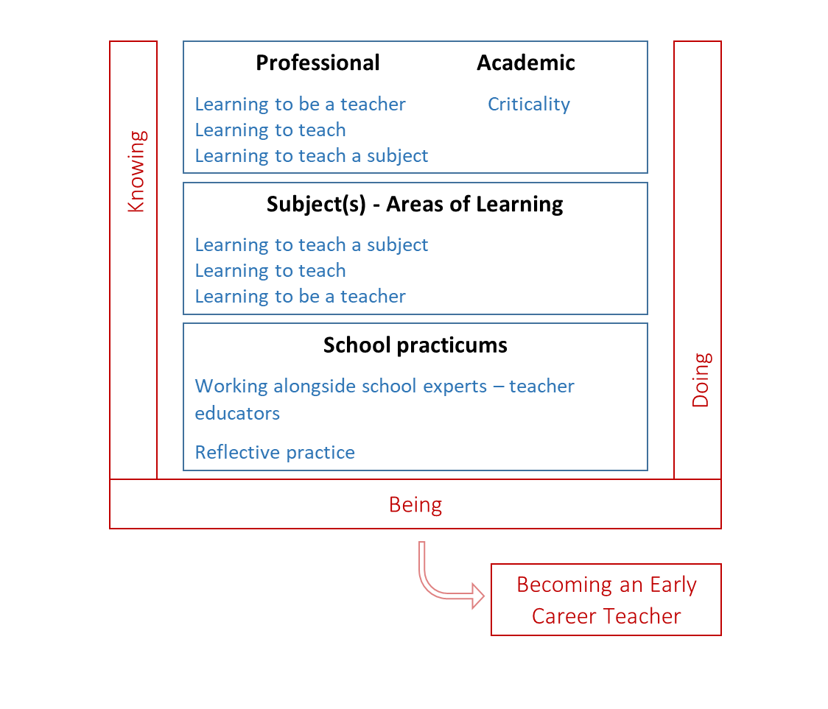
Figure 1.1 Curriculum Framework
- Knowing - The complex and interrelated body of knowledge for teaching and ways of thinking, such as creativity and criticality.
- Doing The multifaceted skills and practices involved in teaching.
- Being Self-awareness that establishes professional identity and responsibilities, and the reflexive relationships with others.

Approximately one third of the course is university-based, with those building blocks focussing on professional and academic issues, with an emphasis on learning to be a teacher, learning to teach, and subject specific elements with a greater emphasis on learning to teach a subject. The majority of the time on the course is spent on school practicums, where our student teachers will work alongside school experts to develop their practice. Whilst the university elements will focus more on the ‘knowing’ and school practicums encompass more ‘doing’, these interlink and will be drawn together, through reflecting upon practice, theory and research, in order to develop student teachers’ professional identity (being).
The PGCE curriculum is set within a number of regulatory frameworks from the Department for Education (DfE), Office for Standards in Education (Ofsted) and Quality Assurance Agency (QAA) for Higher Education. This course therefore draws upon:
- Experiences and expertise of university tutors, Partnership schools, wider professionals and expert colleagues from schools
- DfE (2019) Core Curriculum Framework and DfE (2021) Early Careers Framework; updating to the ITTECF Initial Teacher Training and Early Career Framework (2025)
- DfE (2013) Teachers’ Standards
- Ofsted (2020) Fundamental English and Maths skills
- QAA (2014) Academic skills and integrity of a Master’s level course

Our Partnership Management Group, External Examiners, Student Staff Councils and student teachers and mentor/Mentor evaluations also guide and support the develop and continual improvement of how our curriculum is implemented.

Reflective Practice
Our student teachers will engage in reflective practice which is an integral part in developing a strong professional teaching identity and practice. The following five questions will anchor the students’ reflective practice in five key areas:
- Relationships and Behaviour Management: What is the role of relationships in schools?
- Pedagogy: What does inclusion really mean?
- Curriculum: Why is a broad, balanced and ambitious curriculum important?
- Assessment: What is your understanding of your impact on pupil progress over time?
- Professional Behaviours: How are you developing your teacher identity?
As these will be revisited throughout the range of university and school-based experience this will support the students to remember more, know more and do more as the course progresses.

Key approaches for to implementation
 | University | School
KNOWING: Acquiring knowledge through
Expert Colleagues | Taught sessions by expert tutors and educational professionals  Subject and phase specificity | Observation of expert colleagues  Discussion and analysis with expert colleagues  Analysis and deconstruction of observations of expert colleague practice  Feedback from expert colleagues
Reading and writing | Academic books and articles  Professional sources, including journals  Statutory, policy and advisory documents  Academic assignment writing | School policy documents  School curriculum documents  School data  Planning lessons
Peers | Paired/Group Discussions  Online Discussion Boards | Sharing school experiences
DOING: application of knowledge in an educational context and learning through experience
Practice | Teaching your peers (Microteaching)  Scenarios | Observation and assessment of learning  Deconstruction of own teaching  Teaching small groups  Whole class teaching  Wider school life opportunities (whole staff/phase/subject meetings, parents’ consultation)
Learning from expert colleague | Acting on feedback from tutors | Acting on feedback from school-based experts and university tutors  Deconstruction of observations of teaching approaches
BEING: Developing teacher identity
Reflecting | Theories and practice  Experiences of learning both in university and school | Impact on pupil progress:  - Lesson Evaluations  - Weekly Reviews  - Professional Development
Figure 1.2: Curriculum Implementation
During the PGCE year students can achieve up to 90 Level 7 credits. Our assignments have been designed to empower students to become evidence informed practitioners as outlined in Figure 1.3.
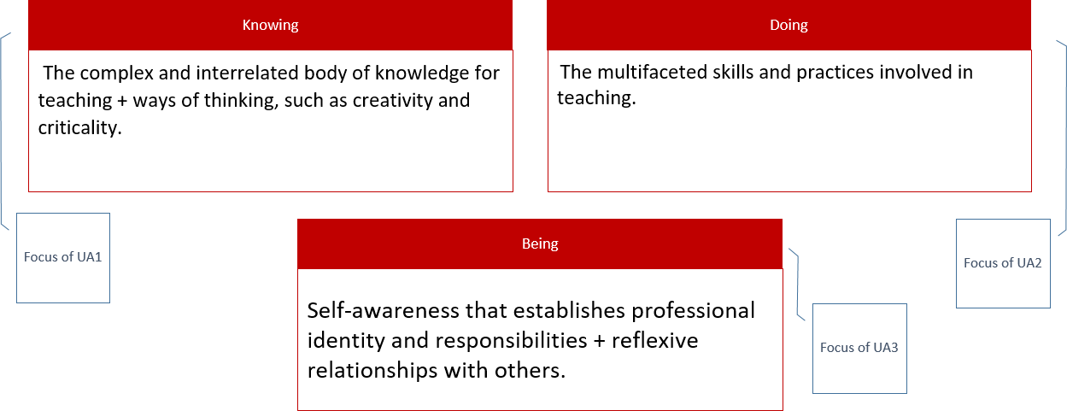
Figure 1.3 Assignment foci

Impact of the of the University of Leicester’s PGCE Curriculum
There are many stakeholders in our partnership, and an effective PGCE curriculum can impact our student teachers and the schools they work in, including pupils. The overarching aim is to have a positive impact on pupils’ education, both during the PGCE course and in future years. The following measures focus on the impact on student teachers which, in turn, will lead to positive outcomes for pupils.
Completion rates and attainment rates will be bench marked against national data. Progression into employment and/or further study opportunities will be monitored. Our impact against our curriculum intentions is outlined in the table below.
Intention | Measures |  | Impact on Student teacher
Intention 1: Being evidence informed practitioners | Academic Assignments  Mentor/Mentor, School Feedback and Observations  End of Phase Reports  Student Evaluation  Quality Assurances:  - Internal Moderation  - Student Evaluations  - School Evaluations  - Partnership Management Group  - External Examiners | Discussions with Students | Able to make educational decisions in the best interest of the pupils.
Intention 2: Having good subject and pedagogical knowledge |  | Subject Knowledge Audits  Students’ Planning /Teaching | Can plan, teach and deliver an inclusive broad and balanced curriculum
Intention 3: Using assessment effectively |  | Students’ Planning | Can use effective assessment strategies to support all pupils’ progress.
Intention 4: Developing positive relationships and behaviours for learning |  | Students’ Teaching | Is responsive to pupils needs enabling them to thrive.
Intention 5: Acting professionally |  | Safeguarding Audit  Certificate Teacher and Law | Demonstrates appropriate professional conduct.

Roles and Responsibilities
Mentor: An expert colleague and subject teacher who takes responsibility for the student teacher’s subject work within the school or college, and assesses their progress within the subject domain and against the course curriculum
ITE Coordinator: A senior member of the teaching staff within the school or college who has an over-arching responsibility for overseeing student teachers’ work during the school practicum. They organise induction, whole school training events for PGCE students in school and is the school's Registered Assessor for the PGCE programme. They have an important role in supporting and assessing student teachers’ progress and should be the first point of contact if issues arise which cannot be resolved in discussion with the Mentor.
University Tutor: A curriculum subject specialist who is responsible for providing the taught subject sessions at the university, assessing written assignments, and moderating the assessments made by Mentors in the subject. The University Tutor maintains an overview of progress, and is normally the link between student teachers and the academic administration

Induction to the school/ college
The ITE Coordinator should:
- Provide student teachers with a Welcome/ Induction Pack.
- Provide student teachers with information about the school, the local community and the pupils
- Arrange a tour of the school.
- Check that student teachers know where things are to be found.
- Provide student teachers with a school email log in and include them in whole school communications and briefings
- Introduce student teachers to the day-to-day routines of the school.
- Inform student teachers of the school’s Safeguarding procedures.
- Inform student teachers about the school’s behaviour policy - rules, rewards and sanctions.
- Inform student teachers of marking policies
- Ensure that student teachers are fully informed about systems of provision for pupils with SEND and have access to data.
- Inform student teachers of the school's Equal Opportunities Policy.
- Provide Student teachers with information about any relevant current initiatives or legislation.
- Ensure that the student teachers have an individual place to work, and a place to meet and discuss with other student teachers
- Ensure that, for a declared need, any reasonable adjustments are made if necessary
The Mentor should:
- Introduce student teachers to departmental staff, including support staff, and explain responsibilities within the department.
- Give information about departmental resources, including books, worksheets, software, practical resources, photocopying facilities, etc.
- Allocate some work, storage space and reprographic resources for the student teacher.
- Explain departmental homework policy and assessment practice, including internal testing procedures.
- Give information about external exams and specifications.
- Explain departmental schemes of work, including expected levels of attainment.
- Explain pupil grouping practice.
- Give information on department meetings and in-service training events.
- Discuss behaviour policy, rewards and sanctions and sources of support on discipline.
- Explain departmental provision for Special Educational Needs and Disabilities

‘Settling in’ Report
This is a brief report sent to the university in the second week of the school practicum, by the Coordinator, to check if the student teacher has settled into their school, The Secondary PGCE office will send out a link to the Coordinator to do this.

Phase A Practicum – Setting the Foundations
The table below outlines the overall structure of the curriculum trajectory. It contains the 5 areas related to the CCF structure plus the Academic: Postgraduate Study area.
The Focus for Phase A, Knowing and Doing columns provide the ‘highlights’ of this ‘Setting the Foundation’ phase. The top section, in pink, is assessed by university tutors.
Theme | Focus for Phase A | Knowing | Doing
Postgraduate Responsibilities | Integrity | Academic conventions | Accurate referencing
Research Literate | Criticality | Synthesis and analysis | Critique practice using evidence
Reflective Practice | Reflection developing practice | Models of reflection | Weekly meetings
Professional Behaviours (S8) | Professionalism, keeping children safe | PPC | Ongoing esp. in school
Beliefs and Values | Identity, expectations | Impact of expectations | Use appropriate language
Behaviour Management (S7) | Routines, de-escalation/restoration | Role of routines | Consistency
Learning Environment (S1) | Relationships, classroom norms | Role of mutual respect | High expectations
How pupils learn (S2) | Schools of thought (learning, pedagogy) | Main theories | Relate to practice
Planning (S4) | Sequencing learning opportunities | Key features of lessons | Sequence lessons with support
Adaptive Teaching (S5) | Inclusion, inc. SEND, SES, PP EAL | Principles of inclusion | Adapt lessons with support
Subject Curriculum (S3) | Subject & pedagogical content knowledge | Key subject concepts | Use good examples, models
Curriculum (S3) | Curriculum knowledge and design | Statutory guidance | Engage with school curriculum
Assessment (S6) | Summative and formative assessment | Types of assessment | Plan for assessment

Review points in Phase A
Formerly, professional judgments about student teachers’ progress were made against the Teachers’ Standards. Co tutors have used their professional expertise to view these standards through the lens of their subject and in relation to the standards expected for trainee teachers and the context in which they are working.
We will be drawing on your professional expertise to make these same judgments against the curriculum benchmark statements.
The Teachers’ Standards are not used for assessment during Phase A
For each key statement:
Interim report ‘Engaged’ is asking if the student teacher has engaged appropriately with that area given the level and range of experience they have met in the first few weeks. Occasionally, such as for safeguarding, this will be secure yes/no for both reports.
Final report – Secure relates to the statement(s) in green, which have been written to articulate what would be expected at this stage of the course (not the standard expected at the end of the course)
For each of the five areas
Final report – Overall: On track to indicate a ‘best fit’ for that area as to whether the student has made progress that would put them on a trajectory to successfully compete the course – they are not expected to be secure in all areas. In this Phase, the student teachers are not expected to demonstrate all skills independently; If “the student teacher is able to… with appropriate support and guidance” they meet ‘secure’ at this stage of the course.

This table shows the review points in Phase A, when a report is sent to the university. The record is kept on the CARD (Curriculum, Assessment and Review Document), which this year is on a spreadsheet.
After completing the interim report and Final Phase A report please email the file to the PGCE office.
Please name the file in the following way: SURNAME First name Subject Phase A interim/final report
The student teacher is expected to upload a pdf of the summary sheet (the first sheet in the file) to Blackboard and keep a copy of the whole CARD in their university Onedrive.

Review point | What | Deadline | Who | Moderation/ QA
Week 9  (2nd week of practicum) | ‘Settling in’ report | Friday 31 October | Coordinator | Coordinator reports on how well the student has settled in
Week 12 | Interim Phase A Report | Friday 21 November | Mentor | SD Mentors to ensure that SD Lead Schools are sent a copy
Week 16 | Final Phase A Report | Friday 19 December | Mentor | Countersigned by Coordinator; SD Mentor/Coordinators to ensure that SD Lead Schools are sent a copy
Week 24 | Student Progress Review  Targeted Action Plans for identified students in need of additional support |  | University tutors | Student progress meeting

Teaching Timetable for Phase A
The expectation for Phase A is that student teachers have a timetable that represents 50% of an ECT’s teaching load. This should include a range of classes.
The first week is used for observation and preparation; gathering data and information about the classes. In the second week the student teacher can begin teaching, but not all of their classes straight away. The professional judgement of the Mentor, in discussion with the student teacher, will inform decisions about this, but it is expected that by Course Week 11/12 (by mid Nov) the student teacher will have taken on all their timetabled classes. This ‘soft start’ is intended to allow the student teacher to take on more classes as their confidence grows, and to give them time for Focused Observations.
Year 11
Year 11 planning and teaching needs to be included, if the school has Year 11. This does not need to be all of the class’s lessons and can be a combination of team-teaching, small group interventions or part of the lesson. However, the student teacher needs to plan and evaluate their teaching, just as they do for groups that they teach all the time.
Post 16
Post 16 teaching should also be timetabled, if the school has a 6th form. This can be a flexible combination of teaching one lesson per week, additional lessons at lunchtime, intervention with small groups and team teaching. Evidence of planning and evaluation needs to be shown.
PSHE
It is expected that student teachers will be involved in teaching the PSHE curriculum; this will be in addition to their subject teaching. This is likely to be one lesson per week supporting a teacher in Phase A and leading the teaching of PSHE for one lesson a week in Phase B.
Pastoral role
Student teachers should shadow a form tutor during Phase A. In Phase B they will work with a tutor group, so that they are prepared for this role in their ECT year

CARD (Curriculum, Assessment and Review Document)
This is the key document which tracks the student teacher’s progress against our curriculum.
It is organised into the 5 curriculum areas:
- Academic: Postgraduate Study (assessment of this area is the responsibility of the university)
- Professional Behaviours and Values (including CCF5): Learning to be a Teacher
- Behaviour and Relationships (including CCF1): Learning to Teach and Learning to Teach a Subject
- Pedagogy (including CCF2): Learning to Teach and Learning to Teach a Subject
- Curriculum (including CCF3): Learning to Teach and Learning to Teach a Subject
- Assessment (including CCF4): Learning to Teach and Learning to Teach a Subject
Assessment will be based on the professional judgement of Mentors, supported by Coordinators, benchmarked by CARD statements in each curriculum area. As previously, these judgements will draw on observations, professional dialogue and other teaching-related activities. During weekly meetings and when university tutors visit, the Talkthrus will be addressed; this will draw out key aspects of the student’s understanding.

Focussed Observations
Lesson observations by the student teacher, of expert colleagues, is an expectation throughout the school practicum. One formal observation per week is expected, with a record kept by the student teacher and uploaded onto Blackboard. There is a prompt provided for each week in the Phase A practicum and these are linked to the Weekly Focus.
Observing other teachers’ lessons is harder than it looks. It is important for student teachers to distinguish between classroom activity and their interpretation of that activity (which will draw on models of learning). The focus given is deliberately narrow, to allow you to look closely at a specific aspect of the classroom. It is important to write in as much detail as possible when observing the lesson, then review and deconstruct with an expert colleague (this can be the Mentor or a class teacher)
It is essential that observation protocols are discussed before a student teacher observes an expert colleague’s lesson

ERF (Evidence Record Form)
This form is used to record observations of the student teacher’s teaching. It can be used for whole lesson observations, or to focus on a specific aspect of teaching.
It is expected that one formal lesson observation per week be done during the school practicum (and every class that the student teacher teaches must be observed once).
Observations can be undertaken by the Mentors or an expert colleague (the class teacher) but it is important that the Mentor communicates with any other expert colleague about agreed current targets and priorities, so that the student teacher is not overloaded. The ERF should be shared with the student teacher who will upload it onto Blackboard.

Weekly reflections / Weekly emails to student teachers and Mentors
The weekly reflections were started by student teachers in Week 1 of the course. Reflective entries are prompted by questions linked to key reading and are recorded on blackboard.
During the school practicum, there are Student Reflections; these are reflective responses to prompt questions which are linked to our curriculum. A weekly email to student teachers from the university provides these prompts and guidance is also emailed weekly to Mentors. Students will also have a copy of the reflections on the school placement blackboard. Student teachers should have completed the reflection before the weekly meeting.

Blackboard and Eportfolio
Student teachers are responsible for keeping all their records up to date in their university OneDrive. Some of these records should be uploaded each week onto blackboard. This is a course requirement.
During school practicums, student teachers will be uploading their lesson plans, evaluations/ reviews, ERFs (Evidence Record Forms), Weekly Meeting Record and their CARD (Curriculum, Assessment and Review Document) to Blackboard.

University Tutor QA/ Moderation Visits
University- led (Core) student teachers: Each student teacher is normally visited ONCE per placement by their University tutor.
As part of Quality Assurance, each visit will include:
- a discussion of the student teacher’s progress against the curriculum benchmarks (CARD) and, if appropriate, a Talkthru
- a discussion of current targets

The student teacher must have the relevant files uploaded onto Blackboard at the time of this visit, to include:

- Lesson plans, reviews/ evaluations
- ERFs
- Weekly Meeting Record
- CARD (Curriculum, Assessment and Review Document)

School Direct Students: The Lead school will arrange visits to each student teacher. A university tutor will visit each Lead school as part of the QA arrangements.

Support Plan/Action Plan
A cause for concern can be raised by a Mentor, University tutor or ITE Coordinator at any stage in the course and when any aspect of a student teacher's work gives rise to doubts about their ability to proceed to QTS. If a student teacher is School Direct, the Lead Alliance Coordinator/ Director must be the first point of contact.
A Support Plan should identify specific targets for the student teacher to achieve by a set date and to be shared with ALL parties (University, ITE Coordinators – school and Lead, student teacher). In all cases, please share with the University via secpgce@le.ac.uk and headsec@le.ac.uk.
The Support Plan and Action Plan proforma can be downloaded from Blackboard

Commendation
A commendation form can be completed by a University tutor, ITE Coordinator, Mentor or any other member of partnership staff to formally acknowledge outstanding performance by student teachers. These forms are intended to record exceptional performance, significant progress or times when a student teacher has made a notable contribution to an aspect of the PGCE course or an event held in a partnership school. Commendations are discussed by our Panel of Examiners, and formal letters sent to student teachers congratulating them on their success.
A completed commendation form should be emailed to secondary.pgce@le.ac.uk.
The Commendation form can be downloaded from Blackboard

Attendance
During school practicums, student teachers should inform the school of any planned or unplanned absence using the school’s normal procedures, and must inform the university, via the Secondary PGCE office.

Staff List and Key Contacts
Name | Role | Email
Professor Chris Wilkins | Head of School of Education | caw11@le.ac.uk
Jenny Bosworth | Director of ITE | Jb591@le.ac.uk
Dr Jake Halford | Co-Head of Course, History and RE Subject Tutor | fb128@le.ac.uk
Stephanie Oswald | Modern Languages Subject Tutor | sio1@le.ac.uk
Sheila Dennis | English Subject Tutor | sd386@le.ac.uk
Kerry Onyejekwe | Social Science and Humanities Tutor | Ko98@le.ac.uk
Dr Fay Baldry | Mathematics Subject Tutor | jjsh2@le.ac.uk
Dr Jon Heywood | Science Subject Tutor | jh407@le.ac.uk
Shaakirah Kasuji | Geography Subject Tutor (school based) | sk1012@le.ac.uk
Kerry Onyejekwe | Co-Head of Course, Social Science subject Tutor | kao1@le.ac.uk
Adrian Warhurst | Science Subject Tutor | agw13@le.ac.uk
Dr David Wharton | English Subject Tutor | dw199@le.ac.uk
Dan Lathbury | PGCE Partnership Office | pgce.partnership@le.ac.uk
Patrick Dudley | Programme Administrator, Secondary PGCE | secpgce@le.ac.uk

Course Calendar 2025-26
Please note: Whilst in school student teachers follow their school’s holiday pattern (swapping in school days with study days as needed). School holiday patterns do vary – student teachers are expected to check this as soon as they know their placements. (For those on 5 term patterns they may need to discuss this with their Mentor).
Key:
Phase A
Date | Course wk | Uni wk | Monday | Tuesday | Wednesday | Thursday | Friday
01/09/2025 | 1 | 7 | 01/09  First day | 02/09 | 03/09 | 04/09 | 05/09
08/09/2025 | 2 | 8 | 08/09 | 9/09 | 10/09 | 11/09 | 12/09
15/09/2025 | 3 | 9 | 15/09 ITP1: Behaviour | 16/09 | 17/09 | 18/09 | 19/09
22/09/2025 | 4 | 10 | 22/09 | 23/09 In a school  ITP1: Behaviour | 24/09 Rehearse  ITP1: Behaviour | 25/09 In a school  ITP1: Behaviour | 26/09  ITP1 Behaviour
29/09/2025 | 5 | 11 | 29/09 | 30/09 | 01/10 | 02/10 | 03/10
06/10/2025 | 6 | 12 | 06/10 | 07/10 (complete IPT2 whilst in school) | 08/10 | 9/10 | 10/10
13/10/2025 | 7 | 13 | 1 13/10 | 14/10 | 15/10 | 16/10 | 17/10
20/10/2025 | 8 | 14 | 20/10 | 21/10 | 22/10 | 23/10 | 24/10 UA1 Submission
27/10/2025 | 9 | 15 | 2 27/10 | 28/10 | 29/10 | 30/10 | 31/10 Settling in Report
03/11/2025 | 10 | 16 | 3 03/11 | 04/11 | 05/11 | 06/11 | 07/11
10/11/2025 | 11 | 17 | 4 10/11 | 11/11 | 12/11 | 13/11 | 14/11
17/11/2025 | 12 | 18 | 5 17/11 | 18/11 | 19/11 | 20/11 | 21/11  Interim Report
24/11/2025 | 13 | 19 | 6 24/11 | 25/11 | 26/11 | 27/11 | 28/11
01/12/2025 | 14 | 20 | 7 01/12 | 02/12 | 03/12 | 04/12 | 05/12
08/12/2025 | 15 | 21 | 8 08/12 | 9/12 | 10/12 | 11/12 | 12/12
15/12/2025 | 16 | 22 | 9 15/12 | 16/12 | 17/12 | 18/12 | 19/12  Final Report
22/12/2025 | 17 | 23 | 22/12 | 23/12 | 24/12 Bank Holiday | 25/12 Bank Holiday | 26/12 UoL: Closure Day

Phase B
29/12/2025 | 18 | 24 | 29/01UoL: Closure Day | 30/01UoL: Closure Day | 31/01 UoL:Closure Day | 01/01 Bank Holiday | 02/01
05/01/2026 | 19 | 25 | 05/01 | 06/01 | 07/01 | 08/01 | 9/01
12/01/2026 | 20 | 26 | 12/01 | 13/01 | 14/01 | 15/01 | 16/01
19/01/2026 | 21 | 27 | 19/01 | 20/01 | 21/01 | 22/01 | 23/01
26/01/2026 | 22 | 28 | 26/01 | 27/01 | 28/01 | 29/01 | 30/01
02/02/2026 | 23 | 29 | 02/02 | 03/02 | 04/02 | 05/02 | 06/02
09/02/2026 | 24 | 30 | 1 9/02 | 10/02 | 11/02 | 12/02 | 13/02
16/02/2026 | 25 | 31 | 16/02 | 17/02 | 18/02 | 19/02 | 20/02  UA2 Submission
23/02/2026 | 26 | 32 | 2 23/02 | 24/02 | 25/02 | 26/02 | 27/02  Settling in Report
02/03/2026 | 27 | 33 | 302/03 | 03/03 | 04/03 | 05/03 | 06/03
09/03/2026 | 28 | 34 | 49/03 | 10/03 | 11/03 | 12/03 | 13/03
16/03/2026 | 29 | 35 | 516/03 | 17/03 | 18/03 | 19/03 | 20/03
23/03/2026 | 30 | 36 | 623/03 | 24/03 | 25/03 | 26/03 Interim Report | 27/03 Return to Uni day
30/03/2026 | 31 | 37 | 30/03 | 31/03 | 1/04 | 2/04 UoL: Closure Day | 3/04Bank Holiday: Good Friday
06/04/2026 | 32 | 38 | Bank Holiday: Easter Monday | 7/04 UoL: Closure Day | 8/04 UoL: Closure Day | 9/04 | 10/04
13/04/2026 | 33 | 39 | 713/04 | 14/04 | 15/04 | 16/04 | 17/04 UA3 Submission UA2 resubmission
20/04/2026 | 34 | 40 | 820/04 | 21/04 | 22/04 | 23/04 | 24/04
27/04/2026 | 35 | 41 | 927/04 | 28/04 | 29/04 | 30/04 | 01/05
04/05/2026 | 36 | 42 | 04/05 Bank Holiday | 10 05/05 | 06/05 | 07/05 | 08/05
11/05/2026 | 37 | 43 | 11 12/05 | 12/05 | 13/05 | 14/05 | 15/05
18/05/2026 | 38 | 44 | 12 18/05 | 19/05 | 20/05 | 21/05 | 22/05Teachers’ Standards Report
25/05/2026 | 39 | 45 | 25/05 Bank Holiday | 26/05 | 27/05 | 28/05 | 29/05
01/06/2026 | 40 | 46 | 13 01/06 | 02/06 | 03/06 | 04/06 | 05/06
08/06/2026 | 41 | 47 | 14 08/06 | 09/06 | 10/06 | 11/06 | 12/06
15/06/2026 | 42 | 48 | 15 15/06 | 16/06 | 17/06 | 18/06 | 19/06 Professional Standards + ECT report
22/06/2026 | 43 | 49 | 16 22/06 | 23/06 Student progress meeting | 24/06 | 25/06 | 26/06  PGCE: Last Day

