University of Leicester Secondary PGCE

Intensive Training and Practice Week 1 (ITP1)
Week 4 (w/b 22 September 2025)
Contents
University of Leicester Secondary PGCE 1
Intensive Training and Practice Week 1 (ITP1) 1
Aims and Focus: 1
Safeguarding 2
5 element framework 2
Timetable 2
Monday 15 September (university) 2
Wednesday 17 September (university) 2
Tuesday 23 September (in school) 2
Wednesday 24 September (university) 2
Thursday 25 September (in school) 2
Friday 26 September (individual work) 3
Link to Card A, Curriculum Area C, Behaviour and Relationships 3
Link to CARD A, Curriculum Area B, Professional Behaviour and Values 3
Link to Core Content Framework 4
Secondary PGCE ITPs 5
References: 5

Aims and Focus:
Student-teachers focus intensively on one element of their curriculum, Behaviour and Relationships, with activities at university and in school that blend theory and practice (Knowing and Doing), with the opportunity to notice, observe, deconstruct, analyse, discuss, reflect, prepare, rehearse, refine and practice. They receive feedback from expert colleagues to help them develop their understanding of this element and embed it into their practice.
An understanding of professional conduct and relationships is also developed during the ITP

Safeguarding
In line with the latest DfE guidance, all students will bring their enhanced DBS certificates with them. All student-teachers will have completed a 90-minute safeguarding session before the ITP week.

5 element framework
ITP1 follows the framework suggested by the National Institute of Teaching
Introduce | Preparation – professional behaviours, observation protocols
Analyse | Observations of routines and interactions, notice, analyse, deconstruct and discuss
Prepare | Prepare scripts, practise and rehearse, refine
Enact | In classrooms with expert colleague, practise
Assess | Reflect and plan

Timetable

Monday 15 September (university)
Student-teachers have introductory sessions on behaviour for learning strategies including rules, routines and relationships

Wednesday 17 September (university)
Student-teachers have sessions today on SEND, inclusion and adaptive teaching; this is included in the preparation for this ITP as student-teachers will be interacting with students in classrooms and need to be aware of all the factors to be taken into account when making observations.
Personal and professional conduct are also revisited.

Tuesday 23 September (in school)
Student-teachers familiarise themselves with a school’s behaviour management policy and follow a student’s timetable in pairs, notice and observe in detail, using prompts, focusing on routines, rules and interactions.
Student-teachers will be using empathy maps to look at schools from a student’s perspective to reflect critically using Brookfield’s four lenses (Brookfield, 1998).

Wednesday 24 September (university)
Student-teachers deconstruct, discuss and reflect on what they observed from students’ perspectives. What did they notice about common routines across schools and departments? They complete their records of their observations.
In groups, they compare their observations and deconstruct them together.
Student-teachers then plan, script and rehearse different routines and discuss

Thursday 25 September (in school)
Again in pairs, student-teachers join a class teacher (this can be within or outside their subject area, as this ITP is not subject focused).
As appropriate, the two student-teachers act as teaching assistants for this teacher(s) for the day and join them for other professional activities (e.g., break duty) if possible, observing.
The focus will be on the student-teacher practising professional interactions with students and staff. This shadowing/teaching assistant role will provide the opportunity to practise interactions with students and staff. This might be through circulating during independent work and supporting students, participating in welcoming the class, helping with entry and exit protocols, handing out resources, giving instructions or working with small groups. (These are just some examples – not all are expected and involvement in alternative activities under the teacher’s direction would be welcomed. The student-teachers will be aware that observation will be part of the day.)
All of this should be underpinned with professional interactions with members of staff – in particular, checking with the teacher what is expected in their classroom. It would be beneficial if the teacher could highlight professional expectations if the student-teachers seem unclear.

Friday 26 September (individual work)
Student-teachers reflect on what they have learnt and work on planning how they can apply this in their future practice.

Link to Card A, Curriculum Area C, Behaviour and Relationships

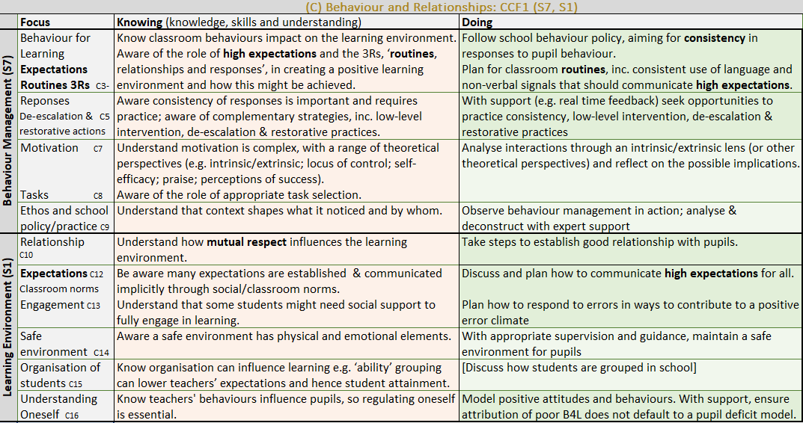

Link to CARD A, Curriculum Area B, Professional Behaviour and Values

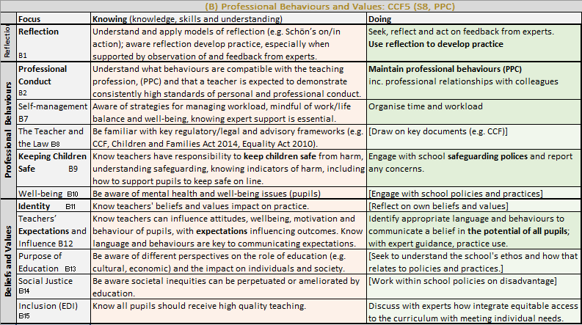

Link to Core Content Framework
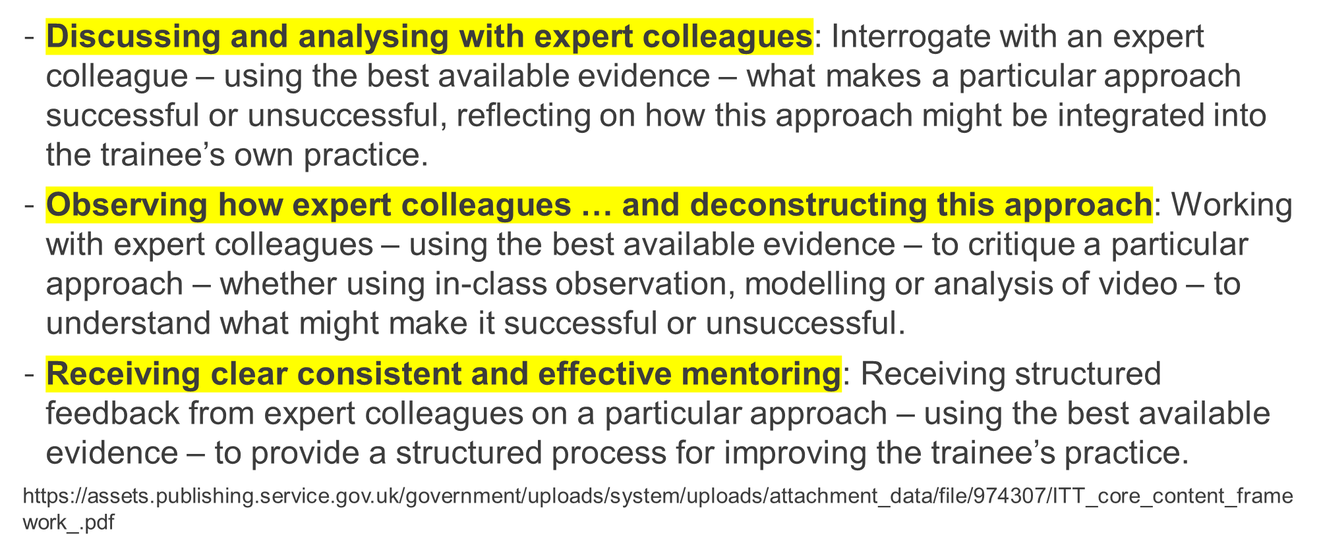

Secondary PGCE ITPs
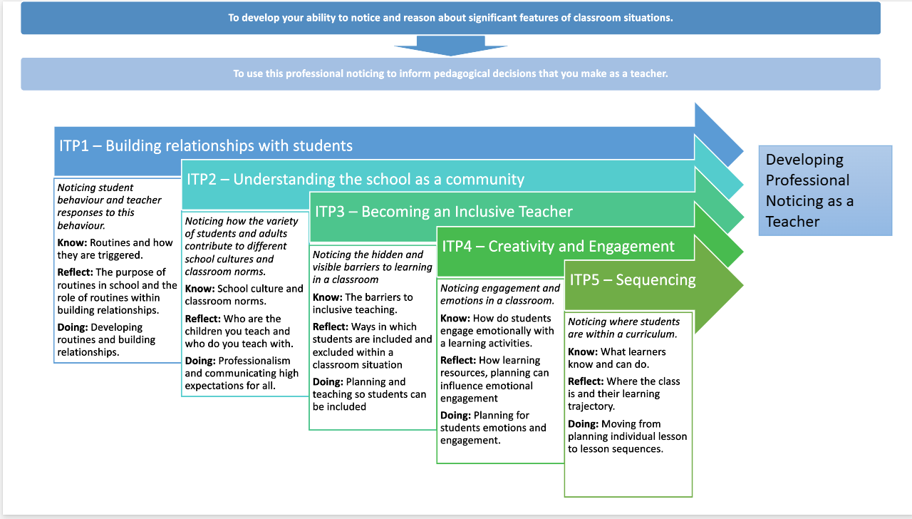

References:

National Institute of Teaching
https://niot.org.uk/news-events/What-is-intensive-training-and-practice
Core Content Framework https://assets.publishing.service.gov.uk/government/uploads/system/uploads/attachment_data/file/974307/ITT_core_content_framework_.pdf
Brookfield, S. (1998) ‘Critically reflective practice’, Journal of Continuing Education in the Health Professions, 18(4), pp. 197–205. Available at: https://doi.org/10.1002/chp.1340180402.
Meyers, S. et al. (2019) ‘Teacher Empathy: A Model of Empathy for Teaching for Student Success’, College Teaching, 67(3), pp. 160–168. Available at: https://doi.org/10.1080/87567555.2019.1579699.
Teding Van Berkhout, E. and Malouff, J.M. (2016) ‘The efficacy of empathy training: A meta-analysis of randomized controlled trials.’, Journal of Counseling Psychology, 63(1), pp. 32–41. Available at: https://doi.org/10.1037/cou0000093.

