ITP 5: Noticing where students are within a curriculum.

ITP aims:
Through this ITP student teachers will be developing their ability to notice learners.
- Know: What learners know and can do.
- Reflect: Where the class is and their learning trajectory.
- Doing: Moving from planning individual lesson to lesson sequences

What is an ITP (Intensive Training and Practice)?
An ITP is a laser-focused opportunity to connect theory and practice in a short time frame. Student teachers work on a key aspect of teaching with live, structured feedback so that they can develop rapidly in foundational areas—knowledge and understanding they can build the rest of their practice upon. In line with the Core Content Framework, ITPs provide focused opportunities to:
- Discuss and analyse a particular approach with expert colleagues
- Observe experts and deconstruct what makes their practice successful (or not)
- Receive clear mentoring and feedback on that approach to improve practice

Professional Noticing: The Core of All ITPs
At the heart of our ITPs is professional noticing—a deliberate, theory-informed way of attending to classroom events and making sense of them through an educational lens. Unlike everyday noticing, professional noticing is intentional and interpretive: teachers attend to specific features of teaching and learning, interpret what they see using disciplinary concepts, and act on those interpretations.
Research indicates that a well-developed capacity for noticing supports novices to navigate the complex, contingent nature of classrooms and to make more informed instructional decisions (e.g., Rooney & Boud, 2018). Our ITPs draw on this body of work and cultivate three complementary strands:
- Noticing in context: recognising that events happen within a messy, dynamic classroom ecology
- Noticing of significance: distinguishing what matters for learning from what is merely visible
- Noticing learning: paying attention to evidence of understanding, partial understanding, and misconception
This orientation aligns with Jacobs et al. (2010), who argue that noticing entails not only attending but also interpreting and responding—a full cycle that moves from observation to action.

Why Noticing Where Students Are in the Curriculum Matters
A crucial dimension of professional noticing is the ability to locate learners within a curriculum sequence. Curriculum-aligned noticing situates classroom observations within a progression of knowledge and skills, recognising that learning is cumulative and that each new idea rests on secure prior understanding. When teachers can identify what has been mastered, is emerging, or remains insecure, they are better placed to make responsive decisions: when to move on, when to consolidate, and where to address misconceptions before introducing new content. This makes curriculum-aligned noticing a powerful form of formative assessment, helping teachers to maintain coherence across lesson sequences and ensuring that instruction remains both ambitious and achievable.

Why This Is Especially Important at the Start of Placement
The opening days of a placement are pivotal. Student teachers often inherit classes mid-sequence, with established routines, partially learned concepts, and upcoming assessment demands. Engaging in curriculum-aligned noticing at this stage enables student teachers to:
- Map the intended curriculum (schemes, MTPs, specifications) against the enacted curriculum (what pupils can currently do)
- Identify gaps, misconceptions, or strengths that will shape immediate planning
- Anticipate the next steps in the sequence so that lessons are pitched neither behind nor ahead of learners’ readiness
In effect, noticing acts as a bridge between observing a class and confidently teaching it. By developing this skill in the first days, student teachers are positioned to plan responsive lessons, support progression across sequences, and make decisions that align with departmental expectations and students’ actual needs.

The Noticing Cycle: Know → Reflect → Doing
To make professional noticing practical and habitual, we use the Noticing Cycle:
- Know – Elicit and collate evidence of what learners know and can do relative to the curriculum (books, quick checks, cold tasks, observation notes).
- Reflect – Interpret that evidence against the curriculum map and the class’s learning trajectory: what is secure, partial, or missing? what needs to be revisited?
- Doing – Respond by planning teaching that connects prior learning to next steps within a coherent sequence of lessons (not just a single lesson), embedding formative checks to keep the sequence responsive.

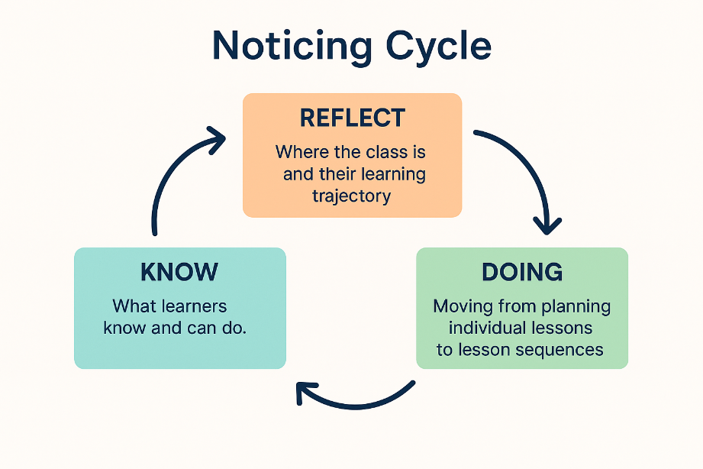

ITP Activities
These activities should be completed in the first week of your placement and should be done in order.

Stage 1: KNOW
These activities will help you to notice what learners know and can do.

Activity 1: Explore Key Curriculum Documents
Purpose: Build a secure understanding of what students should know at this point.
Actions:
- Locate the curriculum documentation for your subject/Key Stage
  - National Curriculum or exam board specifications
  - Department schemes of work
  - Medium term plans (MTPs) and unit overviews
- Highlight:
  - Core knowledge for the current unit
  - Skills progression
  - Prior knowledge expectations
  - Future knowledge this unit prepares students for
Output:
For one of the year groups that you will be teaching create a short summary for what the students should know by this point, what they should be able to do.

Activity 2: Analyse a Medium-Term Plan
Purpose: Understand the intended learning sequence the class is working through.
Actions:
- Identify the position of the current unit within the MTP. If yoru department does not have a medium term plan use the scheme of work to locate where they are.
- Note lesson objectives already covered
- Identify the next 2–4 lessons planned
Output:
A visual timeline showing:
- What has been taught
- What is being learned now
- What is coming next

Activity 3: Observe Lessons with a Knowledge-Checking Focus
Purpose: Notice what students actually know and can do, not just what was intended.
Preparation
Before you observe the class. Using your analysis of the school curriculum documents make a note in the table below of what knowledge/skill you would expect to be able to see in the class.
Focus questions:
- What prior knowledge do students recall easily in a lesson?
- Where do students hesitate or rely on prompts?
- Which students are secure, partially secure, or struggling?
- What types of misconceptions appear repeatedly?

Knowledge/Skill | Evidence of Security | Misconceptions | Notes

Stage 2: Reflect
These activities will help you to reflect on where the class is now and their learning trajectory.

Activity 4: Compare Intended Curriculum vs. Actual Learning
Purpose: Form a realistic picture of the class’s place in the school curriculum
Actions:
- Compare what you observed with what you found from looking at the curriculum documents
- Identify:
  - Content that is secure
  - Content partially secure
  - Content not yet mastered
  - Necessary foundation knowledge that needs revisiting
Key reflective questions:
- Can the next lesson proceed as planned?
- Does anything need reteaching or strengthening first?
- Are some learners ahead/behind the intended trajectory?
Output:
A written reflection:
“Based on the evidence, students are currently secure in…, developing in…, and require further work on…”

Activity 5: Hold a curriculum conversation with Mentor
Purpose: Align your reflections with expert understanding.
Discussion prompts:
- Do my observations match what you’ve seen recently?
- What differences have you noticed about what students should be able to do and what they can do?
- What small adjustments might strengthen the learning sequence?
- Is the next lesson best positioned as consolidation or progression?

Stage 3: Doing
Moving from planning an individual lesson to lesson sequences.

Activity 6: Identify the 'Next Step' in the Sequence
Purpose: Use curriculum and observations to determine what the next lesson should accomplish.
Actions:
- Decide the most appropriate next learning intention
  - Consolidation?
  - Introducing new content?
  - Addressing a misconception?
- Use evidence from observations and curriculum mapping to justify the choice
Output:
A clear lesson goal linked to the curriculum and pupil needs:
The next lesson should focus on… because students demonstrated…
If possible discuss this with your mentor/class teacher what you noticed.

Activity 7: Plan a micro-sequence of Lessons
Based on what you have observed and learnt draft a micro sequence of lessons for the class showing:
- What the prior knowledge is
- What the learning intention of each lesson will be
- Where assessment for learning will sit
- How lessons connect logically

1. Identify the Starting Point (KNOW)
- Draw on your observations, conversations with the class teacher, and curriculum documents.
- Summarise what students currently know
- Write a brief statement outlining
  - Secure knowledge
  - Partially secure knowledge
  - Common misconceptions or gaps
This should reflect where the class actually is within the curriculum, not just where the plan says they should be.
Check curriculum alignment
Using the Medium-Term Plan (MTP), Exam Specification or department scheme of work, identify:
- What has already been taught
- Where this learning sits in the broader unit
- What the next curriculum expectations are
This ensures your next lessons are coherent and connected.

2. Determine the Purpose of the Sequence of lessons
Decide what the next 3–5 lessons should achieve
- Do students need consolidation of prior learning before progressing?
- Which misconceptions must be addressed?
- What key concept or skill is important in the sequence?
Write a ‘sequence intention’
This is a short, overarching statement that explains the purpose of the whole mini sequence.
Example:
Over these four lessons, students will consolidate their understanding of fractions as operators so they can confidently apply this knowledge when comparing and ordering fractions.

2.3 Consider the cognitive journey
Reflect on:
- What foundational knowledge must be revisited?
- How complexity will increase across the sequence
- Where guided practice and independent practice fit
- How learning will be assessed formatively

3. Plan the sequence

3.1 Lesson Focus
A concise statement of what learners should learn today.
This should link directly to the previous lesson and set up the next.

3.2 Prior Knowledge
Identify what pupils need to recall from:
- Prior lessons in this sequence
- Earlier units or previous year

3.3 New Learning
Outline:
- The concept, skill, or misunderstanding addressed
- Key explanations, models, or worked examples
- Anticipated misconceptions (based on your noticing)

3.4 Link to Next Lesson
For each lesson write a sentence on how the next lesson is linked to this lesson in the table below. Consider:
- Does it build upon this lesson
- How does it develop what they have done this lesson?
- Does it help to consolidate previous learning?
Create a mini plan for the class you will be taking outlining this sequence.
Lesson | Focus | Prior Knowledge | New learning | Link to Next Lesson
1
2
3
4
5

